ACLRS — Patient Portal PHP Evidence
PHP-only implementation evidence. Source code comments have been removed.
PHP 1 — Dashboard Controller Integration
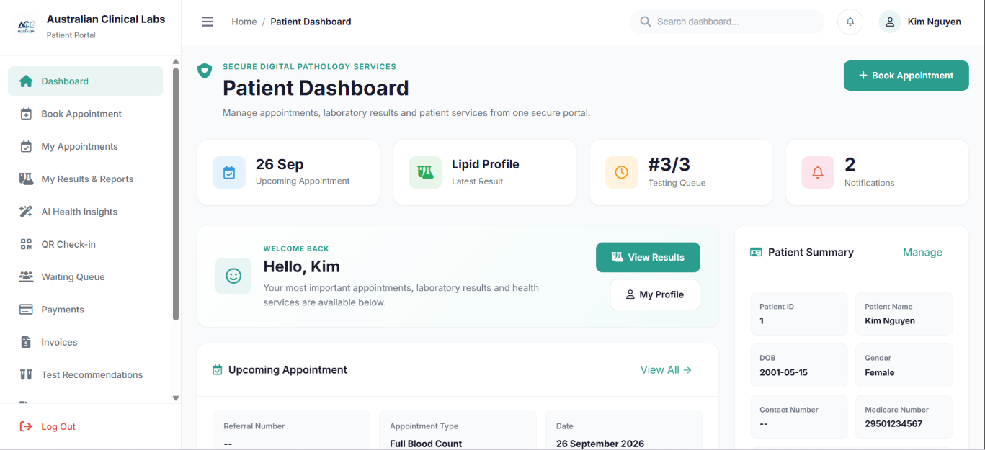
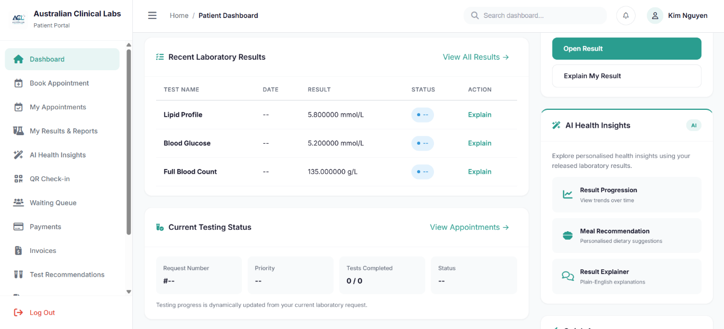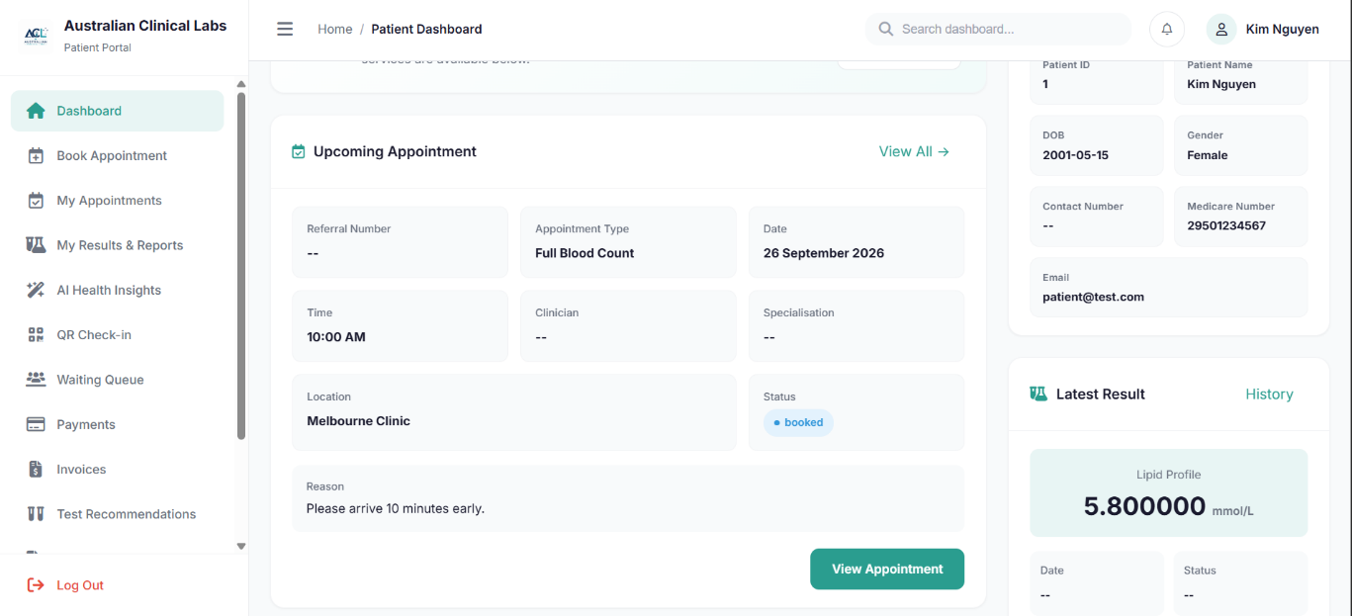
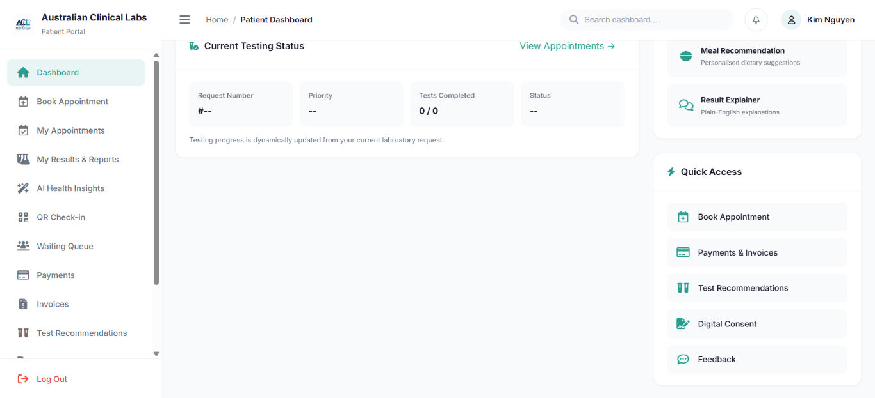

Source file: pages/patient/dashboard.php
PHP controller: pages/patient/controllers/PatientDashboardController.php
Purpose: The Patient Dashboard provides patients with an overview of their current healthcare information and services. The PHP controller retrieves patient-specific dashboard data, including upcoming appointments, the latest lab result, current testing status, and unread notifications.
<?php
require_once __DIR__ . '/controllers/PatientDashboardController.php';
?>

<?php

require_once __DIR__ . '/PatientSession.php.php';

$firstName = htmlspecialchars($patient['first_name'] ?? 'Patient', ENT_QUOTES, 'UTF-8');
$patientIdDisplay = htmlspecialchars((string) $patientId, ENT_QUOTES, 'UTF-8');

$upcomingAppointment = null;

try {

$sqlAppointment = "
SELECT
a.appointment_id,
a.patient_id,
a.test_id,
a.appointment_datetime,
a.location,
a.appointment_status,
a.special_instructions,
a.interpreter_required,
a.interpreter_language,
NULL AS request_id,
tc.test_name,
tc.test_name AS appointment_type,
a.special_instructions AS reason,
NULL AS clinician_first_name,
NULL AS clinician_last_name,
NULL AS specialization
FROM appointments a
LEFT JOIN test_catalogue tc
ON tc.test_id = a.test_id
WHERE a.patient_id = :patient_id
AND a.appointment_status IN ('booked','confirmed','rescheduled')
AND a.appointment_datetime >= NOW()
ORDER BY a.appointment_datetime ASC
LIMIT 1
";

$stmtAppointment = $pdo->prepare($sqlAppointment);

$stmtAppointment->execute([
':patient_id' => $patientId
]);

$upcomingAppointment =
$stmtAppointment->fetch(PDO::FETCH_ASSOC);

} catch (PDOException $e) {

$upcomingAppointment = null;
}

$latestResult = null;
$resultHistory = [];

try {

$sqlResults = "
SELECT
tr.result_id,
tr.result_status AS status,
CASE
WHEN tr.result_numeric IS NOT NULL THEN CAST(tr.result_numeric AS CHAR)
WHEN tr.result_text IS NOT NULL THEN tr.result_text
ELSE '--'
END AS result_value,
COALESCE(lr.report_date, tr.updated_at, tr.created_at) AS result_date,
COALESCE(tr.unit, tp.unit) AS unit,
tr.result_flag,
tc.test_name,
tp.parameter_name,
CASE
WHEN tr.reference_low IS NOT NULL OR tr.reference_high IS NOT NULL
THEN CONCAT(COALESCE(CAST(tr.reference_low AS CHAR), ''), ' - ', COALESCE(CAST(tr.reference_high AS CHAR), ''))
ELSE '--'
END AS reference_range
FROM test_results tr
INNER JOIN test_request_items tri
ON tri.request_item_id = tr.request_item_id
INNER JOIN test_requests req
ON req.request_id = tri.request_id
LEFT JOIN test_parameters tp
ON tp.parameter_id = tr.parameter_id
LEFT JOIN test_catalogue tc
ON tc.test_id = tri.test_id
LEFT JOIN report_results rr
ON rr.result_id = tr.result_id
LEFT JOIN lab_reports lr
ON lr.report_id = rr.report_id
WHERE req.patient_id = :patient_id
AND tr.result_status IN ('authorised','released','corrected')
ORDER BY COALESCE(lr.report_date, tr.updated_at, tr.created_at) DESC, tr.result_id DESC
LIMIT 10
";

$stmtResults = $pdo->prepare($sqlResults);

$stmtResults->execute([
':patient_id' => $patientId
]);

$resultHistory =
$stmtResults->fetchAll(PDO::FETCH_ASSOC);

if (!empty($resultHistory)) {
$latestResult = $resultHistory[0];
}

} catch (PDOException $e) {

$latestResult = null;
$resultHistory = [];
}

$queueStatus = null;

try {

$sqlRequest = "
SELECT
r.request_id,
r.priority,
r.request_status,

COUNT(tri.request_item_id) AS total_tests,

SUM(
CASE
WHEN tri.item_status = 'completed'
THEN 1
ELSE 0
END
) AS completed_tests

FROM test_requests r

LEFT JOIN test_request_items tri
ON tri.request_id = r.request_id

WHERE r.patient_id = :patient_id

GROUP BY
r.request_id,
r.priority,
r.request_status

ORDER BY r.requested_at DESC

LIMIT 1
";

$stmtRequest = $pdo->prepare($sqlRequest);

$stmtRequest->execute([
':patient_id' => $patientId
]);

$request = $stmtRequest->fetch(PDO::FETCH_ASSOC);

if ($request) {

$queueStatus = [
'queue_number' =>
$request['request_id'],

'queue_position' =>
$request['completed_tests'] . '/' .
$request['total_tests'],

'estimated_wait_minutes' =>
'--',

'status' =>
$request['request_status']
];
}

} catch (PDOException $e) {

$queueStatus = null;
}

$notificationCount = 0;

try {

$sqlNotifications = "
SELECT COUNT(*) AS total

FROM notifications

WHERE user_id = :user_id

AND is_read = 0
";

$stmtNotifications =
$pdo->prepare($sqlNotifications);

$stmtNotifications->execute([
':user_id' => $userId
]);

$notificationCount =
(int) $stmtNotifications
->fetchColumn();

} catch (PDOException $e) {

$notificationCount = 0;
}

$latestInvoice = null;

try {

$sqlInvoice = "
SELECT
invoice_id,
request_id,
patient_id,
invoice_number,
issue_date,
due_date,
subtotal,
gst_amount,
total_amount,
invoice_status,
created_at

FROM invoices

WHERE patient_id = :patient_id

ORDER BY issue_date DESC,
invoice_id DESC

LIMIT 1
";

$stmtInvoice =
$pdo->prepare($sqlInvoice);

$stmtInvoice->execute([
':patient_id' => $patientId
]);

$latestInvoice =
$stmtInvoice->fetch(PDO::FETCH_ASSOC);

} catch (PDOException $e) {

$latestInvoice = null;
}

$paymentSummary = [
'pending' => 0,
'paid' => 0
];

try {

$sqlPayment = "
SELECT
pay.payment_status,
COUNT(*) AS total

FROM payments pay

INNER JOIN invoices i
ON i.invoice_id = pay.invoice_id

WHERE i.patient_id = :patient_id

GROUP BY pay.payment_status
";

$stmtPayment =
$pdo->prepare($sqlPayment);

$stmtPayment->execute([
':patient_id' => $patientId
]);

$paymentRows =
$stmtPayment->fetchAll(PDO::FETCH_ASSOC);

foreach ($paymentRows as $payment) {

$status = strtolower(
trim(
$payment['payment_status'] ?? ''
)
);

if ($status === 'pending') {

$paymentSummary['pending'] =
(int) $payment['total'];
}

if (
$status === 'successful' ||
$status === 'paid'
) {

$paymentSummary['paid'] +=
(int) $payment['total'];
}
}

} catch (PDOException $e) {

$paymentSummary = [
'pending' => 0,
'paid' => 0
];
}

$latestMealPlan = null;

try {

$sqlMealPlan = "
SELECT
meal_plan_id,
patient_id,
report_id,
generated_by_user_id,
plan_title,
summary,
recommendation_reason,
ai_model,
plan_status,
created_at

FROM meal_plans

WHERE patient_id = :patient_id

ORDER BY created_at DESC

LIMIT 1
";

$stmtMealPlan =
$pdo->prepare($sqlMealPlan);

$stmtMealPlan->execute([
':patient_id' => $patientId
]);

$latestMealPlan =
$stmtMealPlan->fetch(PDO::FETCH_ASSOC);

} catch (PDOException $e) {

$latestMealPlan = null;
}

$firstName = htmlspecialchars(
$patient['first_name'] ?? 'Patient'
);

$patientIdDisplay = htmlspecialchars(
(string) $patientId
);

?>

PHP 2 — Book Appointment
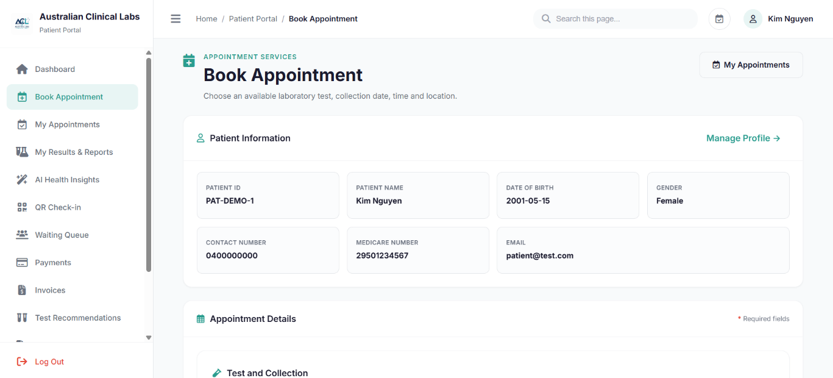
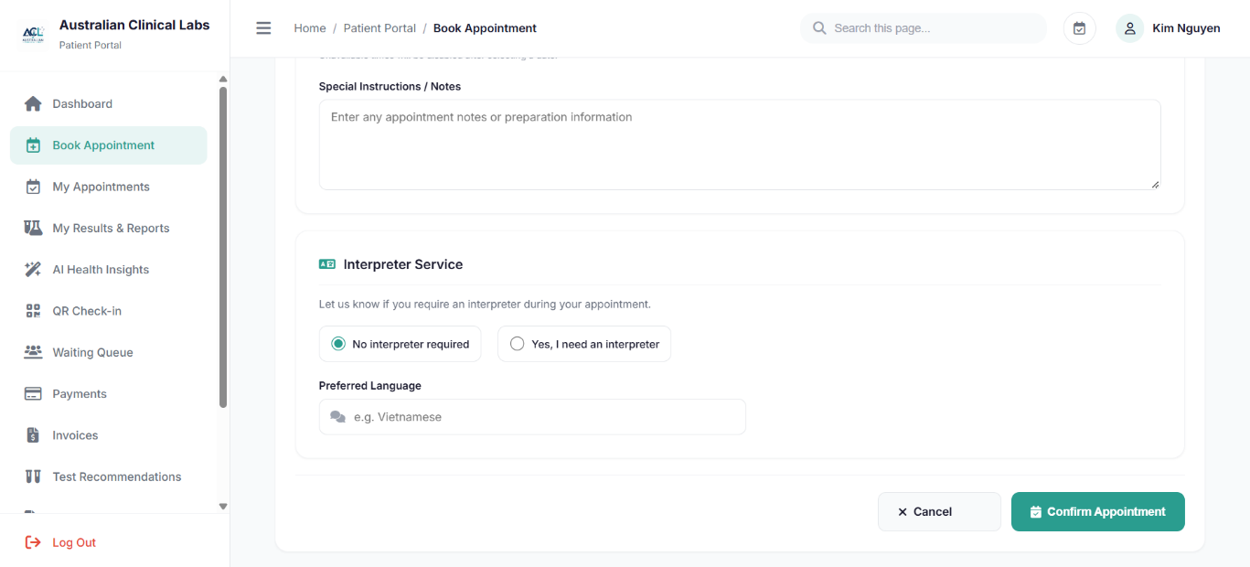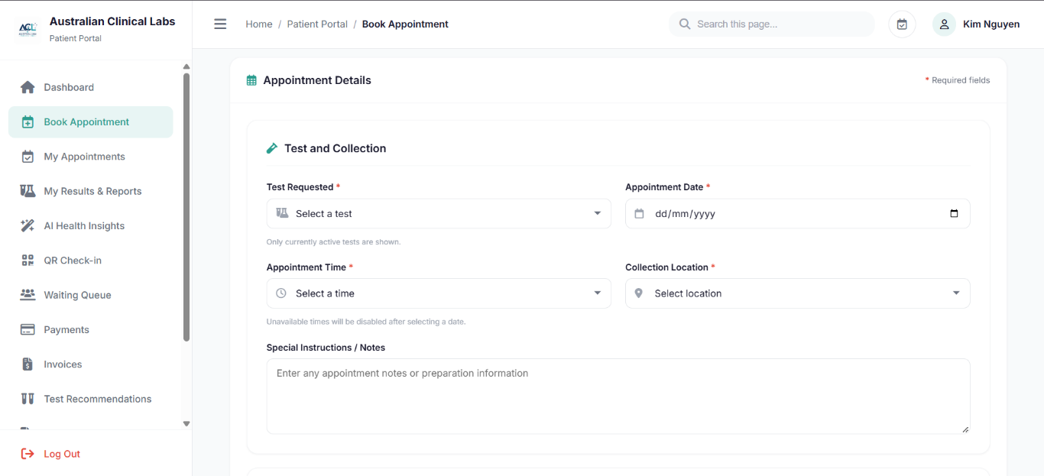

Source file: pages/patient/booking.php
Purpose: Allows patients to book or reschedule laboratory appointments by selecting an active laboratory test, appointment date and time, collection location, and interpreter requirements. The PHP code validates the appointment information, checks appointment availability and stores the booking in the database.
<?php
require_once __DIR__ . '/controllers/PatientSession.php.php';

if (isset($_GET['ajax']) && $_GET['ajax'] === 'booked_times') {

header('Content-Type: application/json; charset=utf-8');

$date = trim($_GET['date'] ?? '');
$location = trim($_GET['location'] ?? '');

$ajaxEditId =
filter_input(
INPUT_GET,
'edit',
FILTER_VALIDATE_INT
) ?: 0;

if (
!preg_match(
'/^\d{4}-\d{2}-\d{2}$/',
$date
)
||
$location === ''
) {

echo json_encode([]);
exit;
}

$startDateTime =
$date . ' 00:00:00';

$endDateTime =
date(
'Y-m-d H:i:s',
strtotime(
$date . ' +1 day'
)
);

$availabilitySql = "

SELECT
DATE_FORMAT(
appointment_datetime,
'%H:%i:%s'
) AS booked_time

FROM appointments

WHERE appointment_datetime >= :start_datetime

AND appointment_datetime < :end_datetime

AND location = :location

AND appointment_status IN (
'booked',
'confirmed',
'rescheduled'
)

AND appointment_id <> :edit_id

ORDER BY appointment_datetime ASC
";

$availabilityStmt =
$pdo->prepare(
$availabilitySql
);

$availabilityStmt->execute([

':start_datetime' =>
$startDateTime,

':end_datetime' =>
$endDateTime,

':location' =>
$location,

':edit_id' =>
$ajaxEditId
]);

echo json_encode(
$availabilityStmt->fetchAll(
PDO::FETCH_COLUMN
)
);

exit;
}

$bookingMessage = '';
$bookingSuccess = false;

$testStmt = $pdo->query("
SELECT test_id, test_code, test_name, specimen_type, test_price,
preparation_instructions
FROM test_catalogue
WHERE active_status = 1
ORDER BY test_name
");
$tests = $testStmt->fetchAll();

$editAppointment = null;
$editId = filter_input(INPUT_GET, 'edit', FILTER_VALIDATE_INT);

if ($editId) {
$editStmt = $pdo->prepare("
SELECT
a.appointment_id,
a.patient_id,
a.test_id,
a.appointment_datetime,
a.location,
a.appointment_status,
a.special_instructions,
a.interpreter_required,
a.interpreter_language,
tc.test_name
FROM appointments a
LEFT JOIN test_catalogue tc ON tc.test_id = a.test_id
WHERE a.appointment_id = :appointment_id
AND a.patient_id = :patient_id
LIMIT 1
");
$editStmt->execute([
':appointment_id' => $editId,
':patient_id' => $patientId
]);
$editAppointment = $editStmt->fetch();

if (!$editAppointment) {
$bookingMessage = 'The selected appointment could not be found.';
}
}

if ($_SERVER['REQUEST_METHOD'] === 'POST') {
$action = $_POST['action'] ?? 'book';

$testId = filter_input(INPUT_POST, 'test_id', FILTER_VALIDATE_INT);
$appointmentDate = trim($_POST['appointment_date'] ?? '');
$appointmentTime = trim($_POST['appointment_time'] ?? '');
$location = trim($_POST['location'] ?? '');
$specialInstructions = trim($_POST['special_instructions'] ?? '');
$interpreterRequired = ($_POST['interpreter_required'] ?? 'No') === 'Yes';
$interpreterLanguage = trim($_POST['interpreter_language'] ?? '');

if (!$testId || $appointmentDate === '' || $appointmentTime === '' || $location === '') {
$bookingMessage = 'Please complete all required appointment fields.';
} elseif ($interpreterRequired && $interpreterLanguage === '') {
$bookingMessage = 'Please enter your preferred interpreter language.';
} else {
$appointmentDateTime = $appointmentDate . ' ' . $appointmentTime;

$dateCheck = DateTime::createFromFormat('Y-m-d H:i:s', $appointmentDateTime);
$today = new DateTime('today');

if (!$dateCheck || $dateCheck->format('Y-m-d H:i:s') !== $appointmentDateTime) {
$bookingMessage = 'Please select a valid appointment date and time.';
} elseif ($dateCheck < $today) {
$bookingMessage = 'Please select a future appointment date.';
} else {

$testCheck = $pdo->prepare("
SELECT test_id, test_name
FROM test_catalogue
WHERE test_id = :test_id
AND active_status = 1
LIMIT 1
");
$testCheck->execute([':test_id' => $testId]);
$selectedTest = $testCheck->fetch();

if (!$selectedTest) {
$bookingMessage = 'The selected test is not available.';
} else {

$slotCheck = $pdo->prepare("
SELECT appointment_id
FROM appointments
WHERE appointment_datetime = :appointment_datetime
AND appointment_status IN ('booked', 'confirmed', 'rescheduled')
AND appointment_id <> COALESCE(:editing_id, 0)
LIMIT 1
");

$slotCheck->execute([
':appointment_datetime' => $appointmentDateTime,
':editing_id' => $editId ?: null
]);

if ($slotCheck->fetch()) {
$bookingMessage = 'The selected appointment time is no longer available. Please select another time.';
} else {
try {
$pdo->beginTransaction();

if ($action === 'reschedule' && $editId) {
$update = $pdo->prepare("
UPDATE appointments
SET
test_id = :test_id,
appointment_datetime = :appointment_datetime,
location = :location,
appointment_status = 'rescheduled',
special_instructions = :special_instructions,
interpreter_required = :interpreter_required,
interpreter_language = :interpreter_language
WHERE appointment_id = :appointment_id
AND patient_id = :patient_id
");

$update->execute([
':test_id' => $testId,
':appointment_datetime' => $appointmentDateTime,
':location' => $location,
':special_instructions' => $specialInstructions !== '' ? $specialInstructions : null,
':interpreter_required' => $interpreterRequired ? 1 : 0,
':interpreter_language' => $interpreterRequired ? $interpreterLanguage : null,
':appointment_id' => $editId,
':patient_id' => $patientId
]);

$bookingMessage = 'Your appointment has been rescheduled successfully.';
} else {
$insert = $pdo->prepare("
INSERT INTO appointments
(
patient_id,
test_id,
appointment_datetime,
location,
appointment_status,
special_instructions,
interpreter_required,
interpreter_language
)
VALUES
(
:patient_id,
:test_id,
:appointment_datetime,
:location,
'booked',
:special_instructions,
:interpreter_required,
:interpreter_language
)
");

$insert->execute([
':patient_id' => $patientId,
':test_id' => $testId,
':appointment_datetime' => $appointmentDateTime,
':location' => $location,
':special_instructions' => $specialInstructions !== '' ? $specialInstructions : null,
':interpreter_required' => $interpreterRequired ? 1 : 0,
':interpreter_language' => $interpreterRequired ? $interpreterLanguage : null
]);

$bookingMessage = 'Your appointment has been booked successfully.';
}

$pdo->commit();
$bookingSuccess = true;

} catch (PDOException $e) {
if ($pdo->inTransaction()) {
$pdo->rollBack();
}
$bookingMessage = 'Unable to save the appointment. Please try again.';
}
}
}
}
}
}

$formTestId = $_POST['test_id'] ?? ($editAppointment['test_id'] ?? '');
$formDate = $_POST['appointment_date'] ?? (
!empty($editAppointment['appointment_datetime'])
? date('Y-m-d', strtotime($editAppointment['appointment_datetime']))
: ''
);
$formTime = $_POST['appointment_time'] ?? (
!empty($editAppointment['appointment_datetime'])
? date('H:i:s', strtotime($editAppointment['appointment_datetime']))
: ''
);
$formLocation = $_POST['location'] ?? ($editAppointment['location'] ?? '');
$formInstructions = $_POST['special_instructions'] ?? ($editAppointment['special_instructions'] ?? '');
$formInterpreter = $_POST['interpreter_required'] ?? (
!empty($editAppointment['interpreter_required']) ? 'Yes' : 'No'
);
$formLanguage = $_POST['interpreter_language'] ?? ($editAppointment['interpreter_language'] ?? '');

?>

PHP 3 — My Appointments
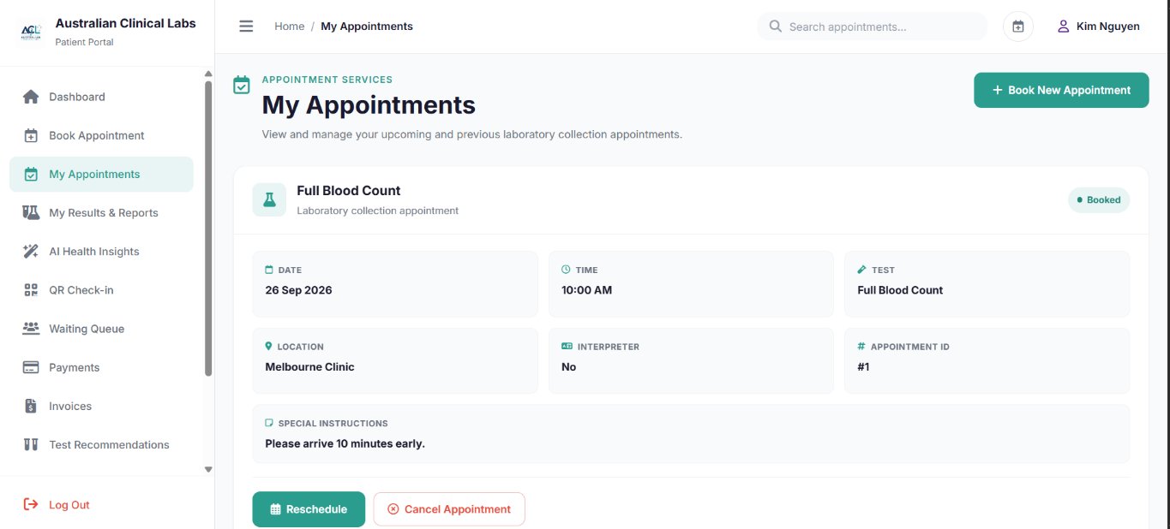
Source file: pages/patient/appointments.php
PHP controller: pages/patient/controllers/AppointmentController.php
Purpose: Allows patients to view and manage their upcoming and previous laboratory collection appointments. The PHP controller retrieves patient-specific appointment information and supports appointment cancellation.
<?php
require_once __DIR__ . '/controllers/AppointmentController.php';
?>

<?php

require_once __DIR__ . '/PatientSession.php.php';

if (!isset($_SESSION['user_id'])) {
header('Location: ../auth/login.php?portal=patient');
exit;
}

$userId = (int) $_SESSION['user_id'];

$stmt = $pdo->prepare("
SELECT
patient_id,
user_id,
patient_identifier,
first_name,
last_name,
date_of_birth,
gender,
phone_number,
email,
medicare_number
FROM patients
WHERE user_id = :user_id
LIMIT 1
");

$stmt->execute([':user_id' => $userId]);
$patient = $stmt->fetch();

if (!$patient) {
session_destroy();
die('Patient account not found. Please sign in with a valid patient account.');
}

$patientId = (int) $patient['patient_id'];
$patientName = trim($patient['first_name'] . ' ' . $patient['last_name']);
$appointmentMessage = '';

if ($_SERVER['REQUEST_METHOD'] === 'POST' && ($_POST['action'] ?? '') === 'cancel') {

$appointmentId = filter_input(
INPUT_POST,
'appointment_id',
FILTER_VALIDATE_INT
);

if (!$appointmentId) {

$appointmentMessage = 'Invalid appointment.';

} else {

$cancel = $pdo->prepare("
UPDATE appointments
SET appointment_status = 'cancelled'
WHERE appointment_id = :appointment_id
AND patient_id = :patient_id
AND appointment_status IN ('booked', 'confirmed', 'rescheduled')
");

$cancel->execute([
':appointment_id' => $appointmentId,
':patient_id' => $patientId
]);

if ($cancel->rowCount() > 0) {

header('Location: appointments.php');
exit;
}

$appointmentMessage =
'The appointment could not be cancelled. It may already be completed or cancelled.';
}
}

$stmt = $pdo->prepare("
SELECT
a.appointment_id,
a.patient_id,
a.test_id,
a.appointment_datetime,
a.location,
a.appointment_status,
a.special_instructions,
a.interpreter_required,
a.interpreter_language,
a.created_at,
a.updated_at,
tc.test_code,
tc.test_name,
tc.specimen_type,
tc.test_price,
tc.preparation_instructions
FROM appointments a
LEFT JOIN test_catalogue tc
ON tc.test_id = a.test_id
WHERE a.patient_id = :patient_id
ORDER BY
CASE
WHEN a.appointment_status IN ('booked', 'confirmed', 'rescheduled') THEN 0
ELSE 1
END,
a.appointment_datetime ASC
");

$stmt->execute([
':patient_id' => $patientId
]);

$appointments = $stmt->fetchAll();

?>

PHP 4 — My Results & Reports
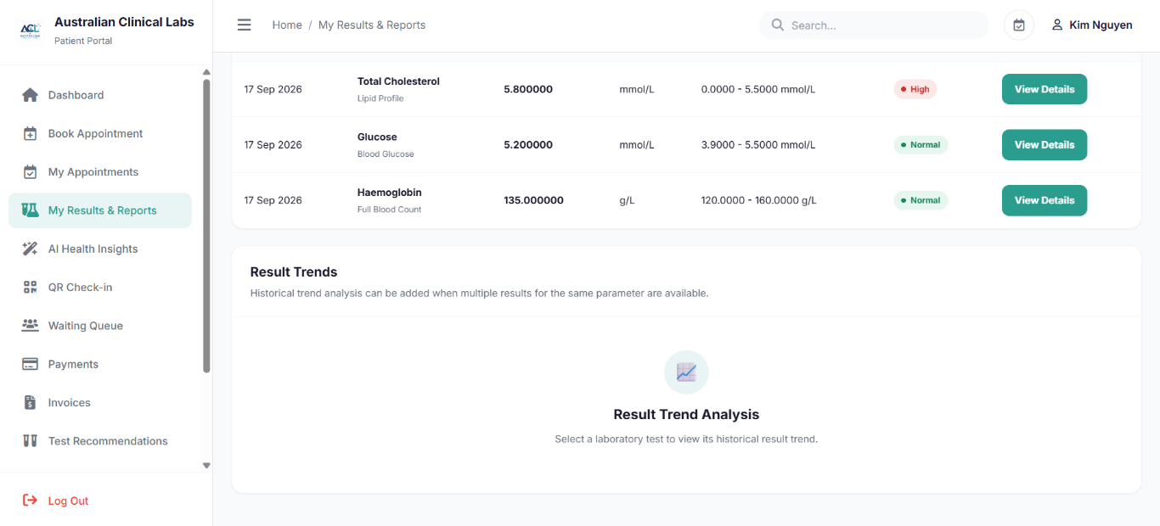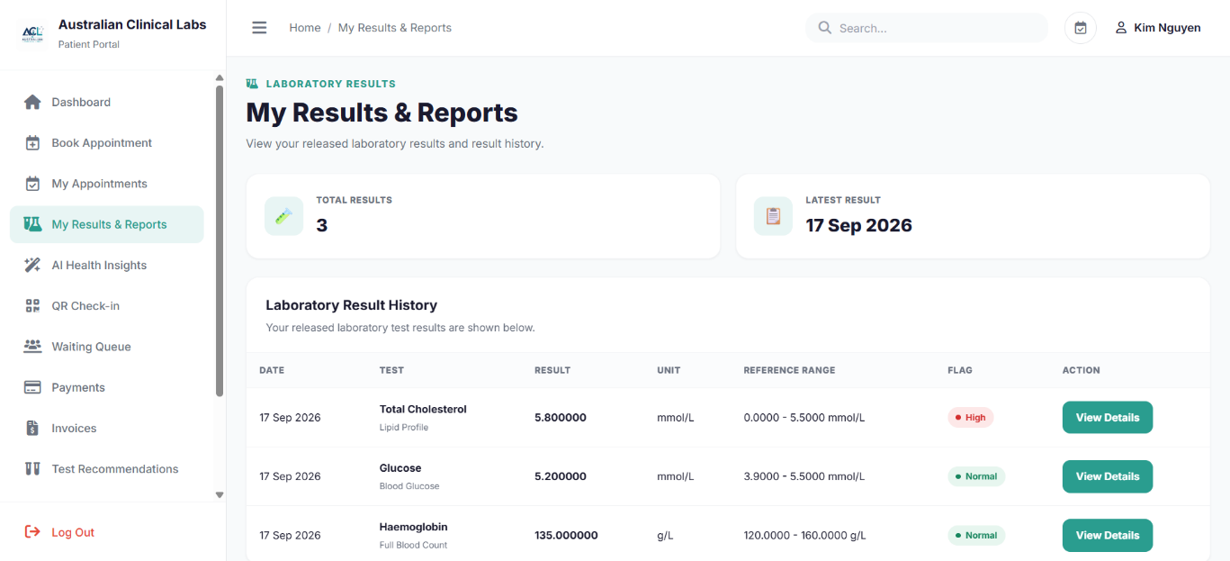
Source file: pages/patient/results.php
PHP controller: pages/patient/controllers/ResultHistoryController.php
Purpose: Allows patients to view their available laboratory results and reports. The PHP controller retrieves laboratory results information associated with the authenticated patient, including test values, reference ranges, result status and related report information.
<?php
require_once __DIR__ . '/controllers/ResultHistoryController.php';
?>

<?php
declare(strict_types=1);

require_once __DIR__ . '/PatientSession.php.php';

$userId = (int) $_SESSION['user_id'];

$stmt = $pdo->prepare("
SELECT
patient_id,
user_id,
first_name,
last_name,
date_of_birth,
gender,
phone_number,
email
FROM patients
WHERE user_id = :user_id
LIMIT 1
");
$stmt->execute([':user_id' => $userId]);
$patient = $stmt->fetch(PDO::FETCH_ASSOC);

if (!$patient) {
http_response_code(404);
die('Patient not found.');
}

$patientId = (int)$patient['patient_id'];
$patientName = trim(($patient['first_name'] ?? '') . ' ' . ($patient['last_name'] ?? ''));

$stmt = $pdo->prepare("
SELECT
tr.result_id,
rr.report_id,
tr.result_numeric,
tr.result_text,
tr.unit AS result_unit,
tr.reference_low AS result_reference_low,
tr.reference_high AS result_reference_high,
tp.parameter_name,
tp.unit AS parameter_unit,
tp.reference_low,
tp.reference_high,
tr.result_flag,
tr.result_status,
tc.test_id,
tc.test_code,
tc.test_name,
lr.report_date,
lr.report_status
FROM test_results tr
INNER JOIN test_parameters tp
ON tr.parameter_id = tp.parameter_id
INNER JOIN test_request_items tri
ON tr.request_item_id = tri.request_item_id
INNER JOIN test_catalogue tc
ON tri.test_id = tc.test_id
INNER JOIN report_results rr
ON tr.result_id = rr.result_id
INNER JOIN lab_reports lr
ON rr.report_id = lr.report_id
INNER JOIN test_requests req
ON lr.request_id = req.request_id
WHERE req.patient_id = :patient_id
AND lr.patient_id = :report_patient_id
AND lr.report_status IN ('final', 'corrected', 'amended')
AND tr.result_status IN ('authorised', 'released', 'corrected')
ORDER BY lr.report_date DESC, tr.result_id DESC
");

$stmt->execute([
':patient_id' => $patientId,
':report_patient_id' => $patientId
]);

$results = $stmt->fetchAll(PDO::FETCH_ASSOC);

$totalResults = count($results);
$latestResult = $results[0] ?? null;
?>

PHP 5 — Result Details
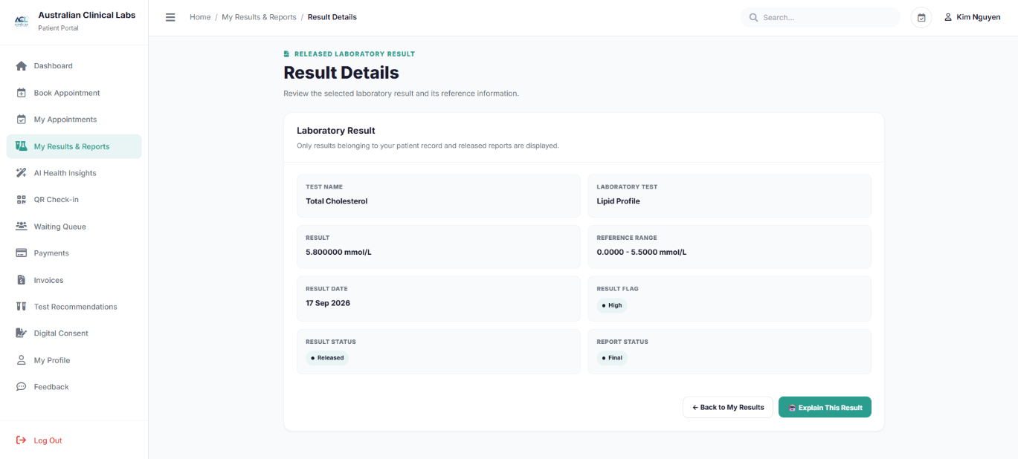
Source file: pages/patient/result-details.php
PHP controller: pages/patient/controllers/ResultExplainerController.php
Purpose: Displays detailed information for a selected laboratory result belonging to the authenticated patient. The PHP controller validates the requested result and retrieves its associated test information, result value, reference range and report details.
<?php
require_once __DIR__ . '/controllers/ResultExplainerController.php';
?>

<?php

require_once __DIR__ . '/PatientSession.php.php';

$userId = (int) $_SESSION['user_id'];

$patientSql = "
SELECT
patient_id,
user_id,
patient_identifier,
first_name,
last_name,
date_of_birth,
gender,
phone_number,
email
FROM patients
WHERE user_id = :user_id
LIMIT 1
";

$patientStmt = $pdo->prepare($patientSql);
$patientStmt->execute([
':user_id' => $userId
]);

$patient = $patientStmt->fetch(PDO::FETCH_ASSOC);

if (!$patient) {
die('Patient record not found.');
}

$patientId = (int)$patient['patient_id'];

$resultId = filter_input(INPUT_GET, 'result_id', FILTER_VALIDATE_INT);

if (!$resultId) {
$resultId = filter_input(INPUT_GET, 'id', FILTER_VALIDATE_INT);
}

if (!$resultId) {
die('Invalid result ID.');
}

$resultSql = "
SELECT
tr.result_id,
rr.report_id,

tr.result_numeric,
tr.result_text,
tr.unit AS result_unit,

tr.reference_low AS result_reference_low,
tr.reference_high AS result_reference_high,

tp.parameter_id,
tp.parameter_name,
tp.unit AS parameter_unit,
tp.reference_low,
tp.reference_high,

tr.result_flag,
tr.result_status,

tc.test_id,
tc.test_code,
tc.test_name,

lr.report_date,
lr.report_status,
lr.clinical_comments

FROM test_results tr

INNER JOIN test_parameters tp
ON tr.parameter_id = tp.parameter_id

INNER JOIN test_request_items tri
ON tr.request_item_id = tri.request_item_id

INNER JOIN test_catalogue tc
ON tri.test_id = tc.test_id

INNER JOIN report_results rr
ON tr.result_id = rr.result_id

INNER JOIN lab_reports lr
ON rr.report_id = lr.report_id

INNER JOIN test_requests req
ON lr.request_id = req.request_id

WHERE tr.result_id = :result_id
AND lr.patient_id = :patient_id
AND req.patient_id = :request_patient_id
AND lr.report_status IN ('final', 'corrected', 'amended')
AND tr.result_status IN ('authorised', 'released', 'corrected')

LIMIT 1
";

$resultStmt = $pdo->prepare($resultSql);

$resultStmt->execute([
':result_id' => $resultId,
':patient_id' => $patientId,
':request_patient_id' => $patientId
]);

$result = $resultStmt->fetch(PDO::FETCH_ASSOC);

if (!$result) {
die('Laboratory result not found or you do not have permission to view it.');
}

$resultFlag = strtolower(trim((string)($result['result_flag'] ?? 'normal')));

if (in_array($resultFlag, ['critical_low', 'critical_high'], true)) {
$resultClass = 'critical';
$resultLabel = 'Critical';

} elseif (in_array($resultFlag, ['low', 'high', 'abnormal'], true)) {
$resultClass = 'abnormal';
$resultLabel = 'Abnormal';

} elseif ($resultFlag === 'not_applicable') {
$resultClass = 'not-applicable';
$resultLabel = 'Not Applicable';

} else {
$resultClass = 'normal';
$resultLabel = 'Normal';
}

if (
$result['result_numeric'] !== null &&
$result['result_numeric'] !== ''
) {
$displayValue = $result['result_numeric'];
} elseif (
$result['result_text'] !== null &&
$result['result_text'] !== ''
) {
$displayValue = $result['result_text'];
} else {
$displayValue = 'N/A';
}

$referenceLow = $result['result_reference_low'];

if ($referenceLow === null || $referenceLow === '') {
$referenceLow = $result['reference_low'];
}

$referenceHigh = $result['result_reference_high'];

if ($referenceHigh === null || $referenceHigh === '') {
$referenceHigh = $result['reference_high'];
}

if (
$referenceLow !== null &&
$referenceLow !== '' &&
$referenceHigh !== null &&
$referenceHigh !== ''
) {
$referenceRange = $referenceLow . ' – ' . $referenceHigh;
} else {
$referenceRange = 'Not available';
}

$unit = $result['result_unit']
?: $result['parameter_unit']
?: '';

$patientName = trim(
($patient['first_name'] ?? '') . ' ' .
($patient['last_name'] ?? '')
);

$aiExplanation = null;
$aiError = null;

if ($_SERVER['REQUEST_METHOD'] === 'POST') {

$action = $_POST['action'] ?? '';

if ($action === 'explain_result') {

$apiKey = getenv('OPENAI_API_KEY') ?: '';

if (!$apiKey) {
$aiError = 'AI service is not configured.';
} else {

$resultName = $result['parameter_name'] ?? $result['test_name'];

$prompt = "
You are an educational laboratory-result assistant.

Explain the following laboratory result in simple language for a patient.

Patient laboratory result:
Test: {$result['test_name']}
Parameter: {$resultName}
Result: {$displayValue} {$unit}
Reference range: {$referenceRange}
Flag: {$resultLabel}

Explain:
1. What this test measures.
2. What the patient's result means compared with the reference range.
3. Possible general reasons for this result.
4. What the patient may wish to discuss with their healthcare professional.

Do not diagnose the patient.
Do not recommend specific medication.
Clearly state that this is general educational information.
";

$payload = [
'model' => 'gpt-5.6',
'input' => $prompt
];

$ch = curl_init('https://api.openai.com/v1/responses');

curl_setopt_array($ch, [
CURLOPT_RETURNTRANSFER => true,
CURLOPT_POST => true,
CURLOPT_HTTPHEADER => [
'Content-Type: application/json',
'Authorization: Bearer ' . $apiKey
],
CURLOPT_POSTFIELDS => json_encode($payload),
CURLOPT_TIMEOUT => 60
]);

$response = curl_exec($ch);

if ($response === false) {

$aiError = 'Unable to connect to the AI service.';

} else {

$httpCode = curl_getinfo($ch, CURLINFO_HTTP_CODE);

$responseData = json_decode($response, true);

if ($httpCode >= 200 && $httpCode < 300) {

$aiExplanation =
$responseData['output_text']
?? null;

if (!$aiExplanation) {
$aiError = 'The AI service returned an empty explanation.';
}

} else {

$aiError =
$responseData['error']['message']
?? 'The AI service returned an error.';
}
}

curl_close($ch);
}
}
}
?>

PHP 6 — AI Result Explainer
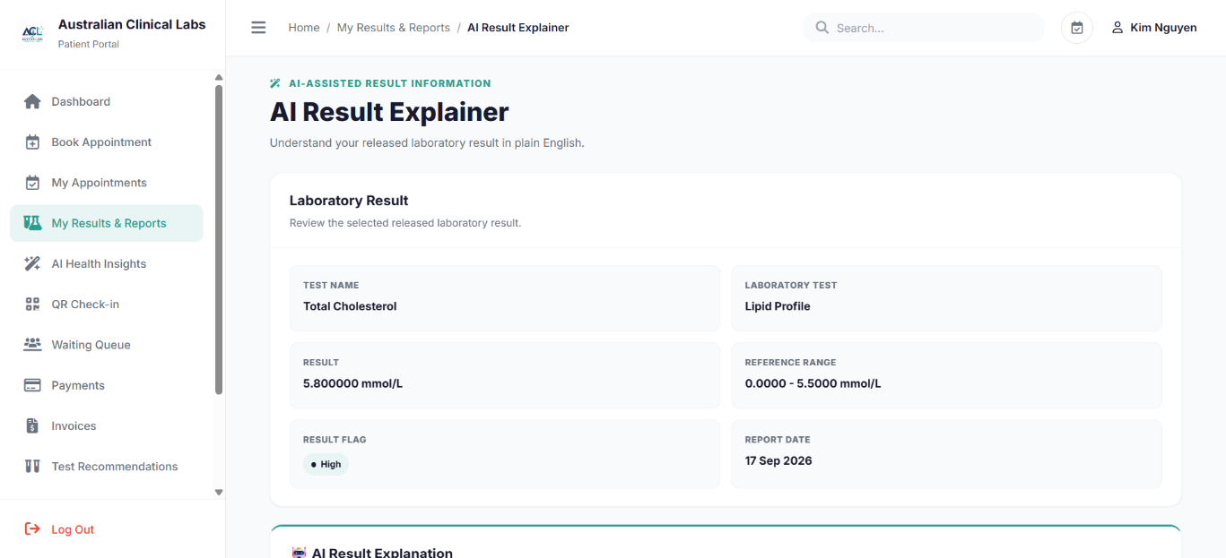

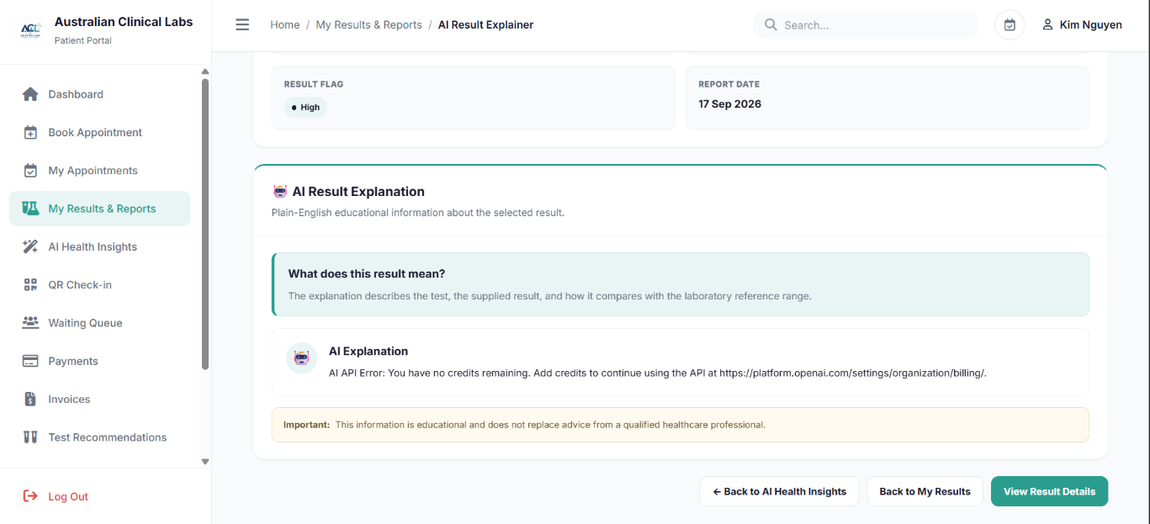
Source file: pages/patient/ai-explainer.php
PHP controller: pages/patient/controllers/AIResultExplainerController.php
Purpose: Provides an AI-assisted explanation of a selected laboratory result. The PHP controller verifies that the requested result belongs to the authenticated patient and is associated with an appropriate laboratory report before providing the result information for AI-assisted interpretation.
<?php
require_once __DIR__ . '/controllers/AIResultExplainerController.php';

$aiExplanation = $_SESSION['ai_explanation'] ?? '';

if (
isset($_SESSION['ai_result_id']) &&
(int)$_SESSION['ai_result_id'] !== (int)$resultId
) {
$aiExplanation = '';
}
?>

<?php
declare(strict_types=1);

require_once __DIR__ . '/PatientSession.php.php';

$userId = (int) $_SESSION['user_id'];

$stmt = $pdo->prepare("
SELECT
patient_id,
first_name,
last_name
FROM patients
WHERE user_id = :user_id
LIMIT 1
");

$stmt->execute([
':user_id' => $userId
]);

$patient = $stmt->fetch(PDO::FETCH_ASSOC);

if (!$patient) {
http_response_code(404);
die('Patient not found.');
}

$patientId = (int)$patient['patient_id'];

$patientName = trim(
($patient['first_name'] ?? '') . ' ' .
($patient['last_name'] ?? '')
);

$resultId = filter_input(
INPUT_GET,
'result_id',
FILTER_VALIDATE_INT
);

if (!$resultId) {
$resultId = filter_input(
INPUT_POST,
'result_id',
FILTER_VALIDATE_INT
);
}

$resultId = (int)($resultId ?: 0);

$result = null;
$explanation = '';
$message = '';

function redirectToExplainer(int $resultId): never
{
header(
'Location: ai-explainer.php?result_id=' .
urlencode((string)$resultId)
);

exit;
}

function getResult(
PDO $pdo,
int $resultId,
int $patientId
): ?array {

$sql = "
SELECT
tr.result_id,
rr.report_id,

tr.result_numeric,
tr.result_text,
tr.unit AS result_unit,

tr.reference_low AS result_reference_low,
tr.reference_high AS result_reference_high,

tr.result_flag,
tr.result_status,

tp.parameter_id,
tp.parameter_name,
tp.unit AS parameter_unit,
tp.reference_low,
tp.reference_high,

tc.test_id,
tc.test_code,
tc.test_name,

lr.report_date,
lr.report_status,
lr.clinical_comments

FROM test_results tr

INNER JOIN test_parameters tp
ON tr.parameter_id = tp.parameter_id

INNER JOIN test_request_items tri
ON tr.request_item_id = tri.request_item_id

INNER JOIN test_catalogue tc
ON tri.test_id = tc.test_id

INNER JOIN report_results rr
ON tr.result_id = rr.result_id

INNER JOIN lab_reports lr
ON rr.report_id = lr.report_id

INNER JOIN test_requests req
ON lr.request_id = req.request_id

WHERE tr.result_id = :result_id
AND lr.patient_id = :patient_id
AND req.patient_id = :request_patient_id

AND lr.report_status IN (
'final',
'corrected',
'amended'
)

AND tr.result_status IN (
'authorised',
'released',
'corrected'
)

LIMIT 1
";

$stmt = $pdo->prepare($sql);

$stmt->execute([
':result_id' => $resultId,
':patient_id' => $patientId,
':request_patient_id' => $patientId
]);

$result = $stmt->fetch(PDO::FETCH_ASSOC);

return $result ?: null;
}

if ($resultId <= 0) {

$message = 'Please select a laboratory result first.';

} else {

$result = getResult(
$pdo,
$resultId,
$patientId
);

if (!$result) {

$message =
'The selected laboratory result could not be found ' .
'or is not available yet.';
}
}

if (
$_SERVER['REQUEST_METHOD'] === 'POST' &&
$result
) {

$resultValue =
$result['result_numeric'] !== null
? (string)$result['result_numeric']
: (
$result['result_text'] !== null &&
$result['result_text'] !== ''
? (string)$result['result_text']
: '-'
);

$unit =
$result['result_unit']
?: $result['parameter_unit']
?: '';

$referenceLow =
$result['result_reference_low']
?? $result['reference_low'];

$referenceHigh =
$result['result_reference_high']
?? $result['reference_high'];

$referenceRange = 'Not available';

if (
$referenceLow !== null ||
$referenceHigh !== null
) {

$referenceRange =
($referenceLow !== null
? $referenceLow
: 'No lower limit')
. ' - '
. ($referenceHigh !== null
? $referenceHigh
: 'No upper limit');

if ($unit !== '') {
$referenceRange .= ' ' . $unit;
}
}

$prompt = <<<PROMPT
You are a laboratory result explanation assistant.

Explain the following RELEASED laboratory result in simple,
patient-friendly English.

Rules:
- Do not diagnose a disease.
- Do not prescribe treatment.
- Do not recommend medication.
- Do not claim that the result confirms or rules out a medical condition.
- Explain what the test generally measures.
- Explain how the value compares with the supplied reference range.
- Explain the supplied result flag in general educational terms.
- If a reference range is unavailable, say that clearly.
- Tell the patient that the information is educational and does not
replace professional medical advice.

Test parameter: {$result['parameter_name']}
Laboratory test: {$result['test_name']}
Result: {$resultValue} {$unit}
Reference range: {$referenceRange}
Flag: {$result['result_flag']}
Report date: {$result['report_date']}

Return a concise explanation with these headings:

1. What this test measures
2. What your result shows
3. Reference range
4. What the flag means
5. Important note
PROMPT;

$apiKey = getenv('OPENAI_API_KEY') ?: '';

if ($apiKey === '') {

$explanation =
'AI is not configured. Please add OPENAI_API_KEY ' .
'to your environment configuration.';

} elseif (!function_exists('curl_init')) {

$explanation =
'AI cannot run because the PHP cURL extension ' .
'is not enabled.';

} else {

$payload = [
'model' => 'gpt-5.6',
'input' => $prompt
];

$ch = curl_init(
'https://api.openai.com/v1/responses'
);

curl_setopt_array($ch, [
CURLOPT_POST => true,

CURLOPT_HTTPHEADER => [
'Content-Type: application/json',
'Authorization: Bearer ' . $apiKey
],

CURLOPT_POSTFIELDS => json_encode(
$payload,
JSON_UNESCAPED_UNICODE
),

CURLOPT_RETURNTRANSFER => true,
CURLOPT_TIMEOUT => 60
]);

$response = curl_exec($ch);

if ($response === false) {

$explanation =
'AI connection error: ' .
curl_error($ch);

} else {

$httpCode =
curl_getinfo(
$ch,
CURLINFO_HTTP_CODE
);

$decoded =
json_decode(
$response,
true
);

if (
$httpCode < 200 ||
$httpCode >= 300 ||
isset($decoded['error'])
) {

$explanation =
'AI API Error: ' .
(
$decoded['error']['message']
?? 'The AI service returned an unexpected response.'
);

} else {

$explanation =
(string)(
$decoded['output_text'] ?? ''
);

if (
$explanation === '' &&
!empty($decoded['output'])
) {

foreach (
$decoded['output']
as $item
) {

if (
($item['type'] ?? '')
!== 'message'
) {
continue;
}

foreach (
($item['content'] ?? [])
as $content
) {

if (
($content['type'] ?? '')
=== 'output_text'
) {

$explanation .=
(string)(
$content['text'] ?? ''
);
}
}
}
}

if (
trim($explanation) === ''
) {

$explanation =
'The AI did not return an explanation.';
}
}
}

curl_close($ch);
}

$_SESSION['ai_explanation'] = $explanation;
$_SESSION['ai_result_id'] = $resultId;

redirectToExplainer($resultId);
}

$aiExplanation =
$_SESSION['ai_explanation'] ?? '';

if (
isset($_SESSION['ai_result_id']) &&
(int)$_SESSION['ai_result_id'] !== $resultId
) {

$aiExplanation = '';
}

?>

PHP 7 — AI Health Insights
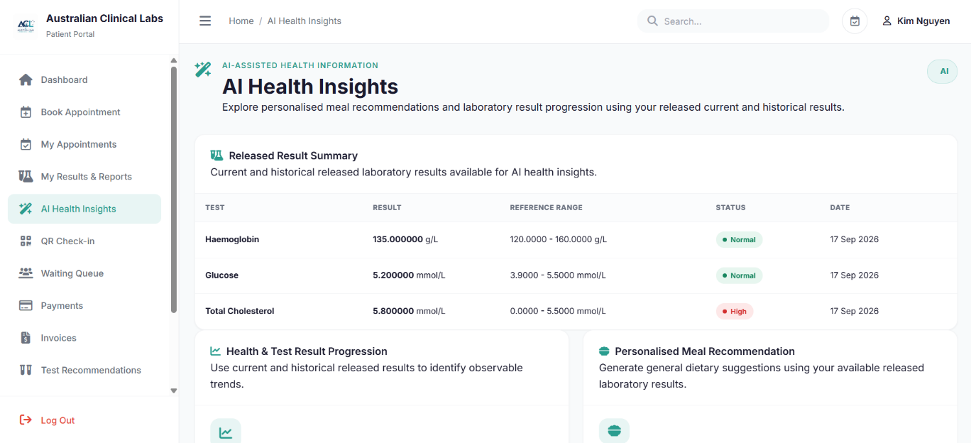
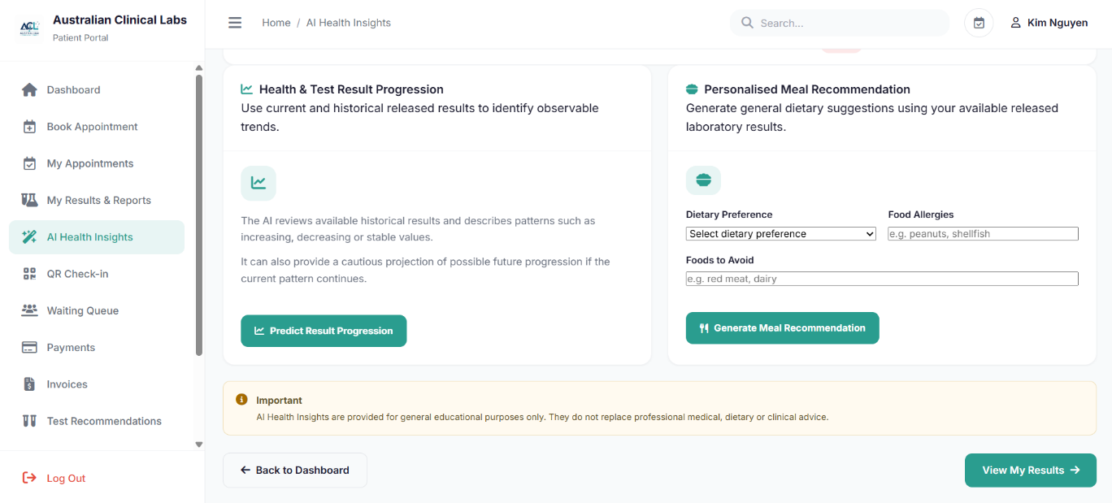
Source file: pages/patient/ai-health.php
PHP controller: pages/patient/controllers/AIHealthController.php
Purpose: Provides AI-assisted health information based on patient and laboratory information. The PHP controller supports health and test-result progression analysis and personalised meal recommendations while retrieving the authenticated patient information required for these AI-assisted functions.
<?php
$message = '';
$messageType = '';

require_once __DIR__ . '/controllers/AIHealthController.php';
?>

PHP 8 — Personalised Meal Recommendation
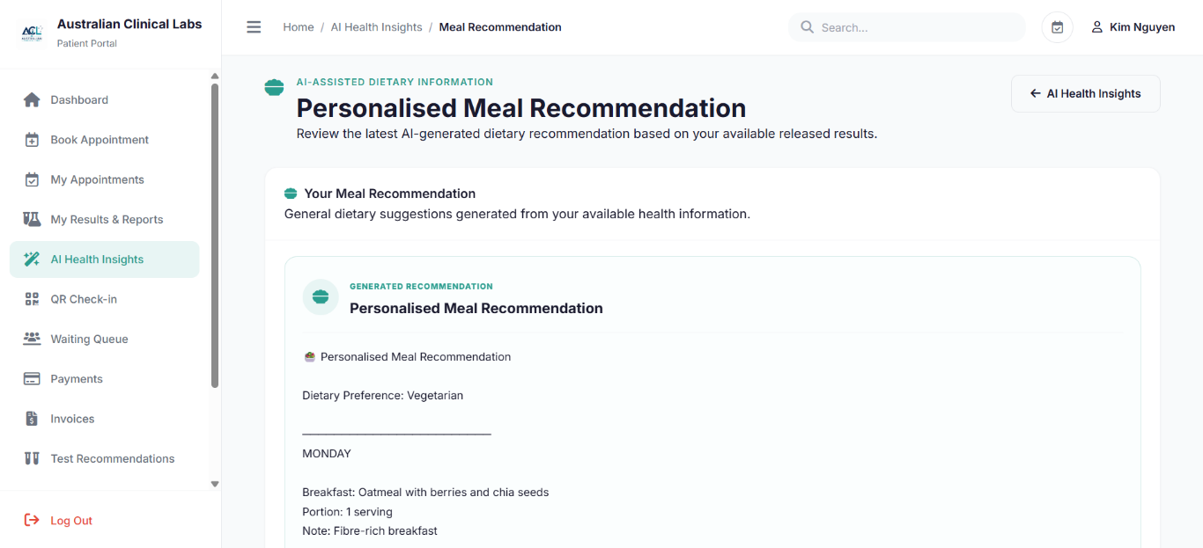
Source file: pages/patient/ai-meal.php
PHP controller: pages/patient/controllers/AIHealthController.php
Purpose: Provides AI-assisted meal and dietary recommendations for the patient. The PHP implementation uses patient and laboratory information to present dietary guidance and meal recommendations relevant to the patient’s available health information.
<?php
require_once __DIR__ . '/controllers/PatientSession.php.php';

$mealPlan = $_SESSION['meal_plan'] ?? '';
$mealPlanId = $_SESSION['meal_plan_id'] ?? null;
$patientName = $_SESSION['patient_name'] ?? 'Patient';

if (trim($mealPlan) === '') {

try {
$patientStmt = $pdo->prepare("
SELECT patient_id
FROM patients
WHERE user_id = :user_id
LIMIT 1
");
$patientStmt->execute([':user_id' => $userId]);
$patient = $patientStmt->fetch(PDO::FETCH_ASSOC);

if ($patient) {
$planStmt = $pdo->prepare("
SELECT
mp.meal_plan_id,
mp.plan_title,
mp.summary,
mp.recommendation_reason,
mp.ai_model,
mp.created_at
FROM meal_plans mp
WHERE mp.patient_id = :patient_id
AND mp.plan_status IN ('generated', 'reviewed')
ORDER BY mp.created_at DESC, mp.meal_plan_id DESC
LIMIT 1
");
$planStmt->execute([':patient_id' => (int)$patient['patient_id']]);
$plan = $planStmt->fetch(PDO::FETCH_ASSOC);

if ($plan) {
$itemStmt = $pdo->prepare("
SELECT
meal_type,
food_name,
portion_description,
nutrition_notes,
reason,
display_order
FROM meal_plan_items
WHERE meal_plan_id = :meal_plan_id
ORDER BY display_order ASC, meal_item_id ASC
");
$itemStmt->execute([':meal_plan_id' => (int)$plan['meal_plan_id']]);
$items = $itemStmt->fetchAll(PDO::FETCH_ASSOC);

$mealPlan = "🥗 Personalised Meal Recommendation\n\n";
$mealPlan .= ($plan['plan_title'] ?? 'Personalised Healthy Meal Plan') . "\n\n";

if (!empty($plan['summary'])) {
$mealPlan .= $plan['summary'] . "\n\n";
}

foreach ($items as $item) {
$mealPlan .= ($item['meal_type'] ?? 'Meal') . ': ' . ($item['food_name'] ?? '') . "\n";
$mealPlan .= 'Portion: ' . ($item['portion_description'] ?? '1 serving') . "\n";

if (!empty($item['nutrition_notes'])) {
$mealPlan .= 'Note: ' . $item['nutrition_notes'] . "\n";
}

$mealPlan .= "\n";
}

if (!empty($plan['recommendation_reason'])) {
$mealPlan .= $plan['recommendation_reason'];
}

$mealPlanId = (int)$plan['meal_plan_id'];
}
}
} catch (PDOException $e) {

}
}
?>

PHP 9 — AI Result Progression
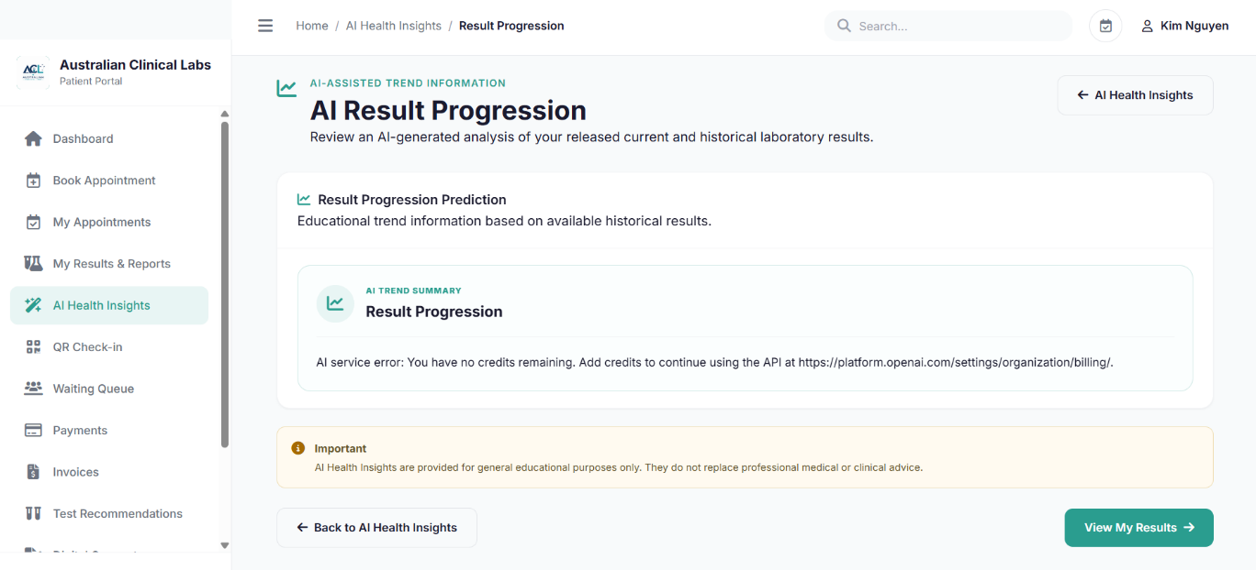
Source file: pages/patient/ai-progression.php
PHP controller: pages/patient/controllers/AIHealthController.php
Purpose: Provides AI-assisted information about the progression and trends of the patient’s laboratory results. The interface presents result progression information to help patients understand changes in their laboratory information over time.
<?php
require_once __DIR__ . '/controllers/PatientSession.php.php';
session_start();

$progressionPrediction = $_SESSION['progression_prediction'] ?? '';
$patientName = $_SESSION['patient_name'] ?? 'Patient';
?>

*Shared PHP for PHP 7, 8, 9
PHP controller: pages/patient/controllers/AIHealthController.php
<?php

require_once __DIR__ . '/PatientSession.php.php';

$userId = (int) $_SESSION['user_id'];

$message = '';
$messageType = '';

$OPENAI_API_KEY = getenv('OPENAI_API_KEY') ?: '';

$stmt = $pdo->prepare("
SELECT
p.patient_id,
p.user_id,
p.first_name,
p.last_name,
p.date_of_birth,
p.gender,
p.phone_number,
p.email,
u.account_status
FROM patients p
LEFT JOIN users u
ON u.user_id = p.user_id
WHERE p.user_id = :user_id
AND (
u.account_status = 'active'
OR u.account_status IS NULL
)
LIMIT 1
");

$stmt->execute([
':user_id' => $userId
]);

$patient = $stmt->fetch(PDO::FETCH_ASSOC);

if (!$patient) {
die('Patient account not found.');
}

$patientId = (int) $patient['patient_id'];

$patientName = trim(
($patient['first_name'] ?? '') . ' ' .
($patient['last_name'] ?? '')
);

$historicalResults = [];

try {

$stmt = $pdo->prepare("
SELECT
tr.result_id,
rr.report_id,

tr.result_numeric,
tr.result_text,
tr.unit AS result_unit,

tr.reference_low AS result_reference_low,
tr.reference_high AS result_reference_high,

tp.parameter_name,
tp.unit AS parameter_unit,
tp.reference_low,
tp.reference_high,

tr.result_flag,
tr.result_status,

tc.test_id,
tc.test_code,
tc.test_name,

lr.report_date,
lr.report_status

FROM test_results tr

INNER JOIN test_parameters tp
ON tr.parameter_id = tp.parameter_id

INNER JOIN test_request_items tri
ON tr.request_item_id = tri.request_item_id

INNER JOIN test_catalogue tc
ON tri.test_id = tc.test_id

INNER JOIN report_results rr
ON tr.result_id = rr.result_id

INNER JOIN lab_reports lr
ON rr.report_id = lr.report_id

INNER JOIN test_requests req
ON lr.request_id = req.request_id

WHERE lr.patient_id = :patient_id
AND req.patient_id = :request_patient_id

AND lr.report_status IN (
'final',
'corrected',
'amended'
)

AND tr.result_status IN (
'authorised',
'released',
'corrected'
)

ORDER BY
lr.report_date ASC,
tr.result_id ASC
");

$stmt->execute([
':patient_id' => $patientId,
':request_patient_id' => $patientId
]);

$historicalResults = $stmt->fetchAll(PDO::FETCH_ASSOC);

} catch (PDOException $e) {

$historicalResults = [];

$message = 'Unable to load laboratory results: ' . $e->getMessage();
$messageType = 'error';
}

$latestReportId = null;

foreach ($historicalResults as $result) {
if (!empty($result['report_id'])) {
$latestReportId = (int) $result['report_id'];
}
}

$progressionPrediction =
$_SESSION['progression_prediction'] ?? '';

$progressionPredictionType =
$_SESSION['progression_prediction_type'] ?? '';

$mealPlan =
$_SESSION['meal_plan'] ?? '';

$mealPlanType =
$_SESSION['meal_plan_type'] ?? '';

$mealPlanId =
$_SESSION['meal_plan_id'] ?? null;

function buildResultText(array $results): string
{
if (empty($results)) {
return "No released laboratory results are currently available.";
}

$text = '';

foreach ($results as $result) {

$value = $result['result_numeric'];

if ($value === null || $value === '') {
$value = $result['result_text'] ?? 'N/A';
}

$unit = $result['result_unit']
?: ($result['parameter_unit'] ?? '');

$referenceLow = $result['result_reference_low'];

if ($referenceLow === null || $referenceLow === '') {
$referenceLow = $result['reference_low'] ?? 'N/A';
}

$referenceHigh = $result['result_reference_high'];

if ($referenceHigh === null || $referenceHigh === '') {
$referenceHigh = $result['reference_high'] ?? 'N/A';
}

$text .= sprintf(
"%s - %s (%s): %s %s " .
"(Reference: %s - %s %s, Status: %s)\n",

$result['report_date'] ?? 'Unknown date',

$result['parameter_name']
?? $result['test_name']
?? 'Laboratory parameter',

$result['test_name'] ?? 'Laboratory test',

$value,

$unit,

$referenceLow,
$referenceHigh,
$unit,

$result['result_flag']
?? 'Not specified'
);
}

return trim($text);
}

function extractOpenAIText(array $responseData): string
{

if (
isset($responseData['output_text']) &&
is_string($responseData['output_text'])
) {
return trim($responseData['output_text']);
}

$text = '';

if (
!empty($responseData['output']) &&
is_array($responseData['output'])
) {
foreach ($responseData['output'] as $outputItem) {

if (($outputItem['type'] ?? '') !== 'message') {
continue;
}

foreach (
($outputItem['content'] ?? []) as $content
) {
if (
($content['type'] ?? '') === 'output_text'
) {
$text .= $content['text'] ?? '';
}
}
}
}

return trim($text);
}

function callOpenAI(string $prompt): array
{
global $OPENAI_API_KEY;

if (
!isset($OPENAI_API_KEY) ||
trim((string) $OPENAI_API_KEY) === ''
) {
return [
'success' => false,
'error' =>
'OpenAI API key is not configured. ' .
'Set the OPENAI_API_KEY environment variable.',
'text' => ''
];
}

$payload = [
'model' => 'gpt-5.6-luna',
'input' => $prompt,
'store' => false
];

$jsonPayload = json_encode(
$payload,
JSON_UNESCAPED_UNICODE
);

if ($jsonPayload === false) {
return [
'success' => false,
'error' => 'Unable to prepare the OpenAI request.',
'text' => ''
];
}

$ch = curl_init(
'https://api.openai.com/v1/responses'
);

curl_setopt_array($ch, [
CURLOPT_RETURNTRANSFER => true,
CURLOPT_POST => true,

CURLOPT_HTTPHEADER => [
'Content-Type: application/json',
'Authorization: Bearer ' . $OPENAI_API_KEY
],

CURLOPT_POSTFIELDS => $jsonPayload,
CURLOPT_TIMEOUT => 60
]);

$rawResponse = curl_exec($ch);

if ($rawResponse === false) {

$error = curl_error($ch);

curl_close($ch);

return [
'success' => false,
'error' => 'Connection error: ' . $error,
'text' => ''
];
}

$httpCode = curl_getinfo(
$ch,
CURLINFO_HTTP_CODE
);

curl_close($ch);

$responseData = json_decode(
$rawResponse,
true
);

if (!is_array($responseData)) {
return [
'success' => false,
'error' =>
'Invalid response received from OpenAI.',
'text' => ''
];
}

if (
$httpCode < 200 ||
$httpCode >= 300 ||
isset($responseData['error'])
) {
return [
'success' => false,
'error' =>
$responseData['error']['message']
?? ('OpenAI API returned HTTP ' . $httpCode . '.'),
'text' => ''
];
}

$text = extractOpenAIText($responseData);

if ($text === '') {
return [
'success' => false,
'error' =>
'OpenAI returned no text output.',
'text' => ''
];
}

return [
'success' => true,
'error' => '',
'text' => $text
];
}

function cleanJson(string $text): string
{
$text = trim($text);

$text = preg_replace(
'/^```json\s*/i',
'',
$text
);

$text = preg_replace(
'/^```\s*/',
'',
$text
);

$text = preg_replace(
'/\s*```$/',
'',
$text
);

return trim($text);
}

function buildMealFallback(
string $diet,
string $allergies,
string $foodsToAvoid
): array {

$restrictionText = strtolower($allergies . ', ' . $foodsToAvoid);

$items = [
['Breakfast', 'Oatmeal with berries and chia seeds', '1 serving', 'Fibre-rich breakfast'],
['Lunch', 'Quinoa and mixed vegetable salad', '1 serving', 'Vegetables and plant protein'],
['Dinner', 'Baked salmon with broccoli and quinoa', '1 serving', 'Balanced main meal'],
['Snack', 'Fresh fruit', '1 small serving', 'Simple snack option']
];

$containsRestriction = static function (string $food) use ($restrictionText): bool {
$restrictions = preg_split('/[,;]+/', $restrictionText);
foreach ($restrictions as $item) {
$item = trim($item);
if ($item !== '' && stripos($food, $item) !== false) {
return true;
}
}
return false;
};

foreach ($items as &$meal) {
if ($containsRestriction($meal[1])) {
$meal[1] = 'Quinoa and mixed vegetable bowl';
}
}
unset($meal);

if (stripos($diet, 'vegan') !== false) {
$veganMeal = 'Tofu and mixed vegetables with quinoa';
$items[2][1] = $containsRestriction($veganMeal)
? 'Lentil and vegetable bowl'
: $veganMeal;
} elseif (stripos($diet, 'vegetarian') !== false) {
$items[2][1] = 'Lentil pasta with mixed vegetables';
}

$days = ['Monday','Tuesday','Wednesday','Thursday','Friday','Saturday','Sunday'];
$meals = [];

foreach ($days as $day) {
foreach ($items as $item) {
$meals[] = [
'day_of_week' => $day,
'meal_type' => $item[0],
'food_item' => $item[1],
'portion_size' => $item[2],
'target_nutrient_note' => $item[3]
];
}
}

return [
'plan_name' => 'Personalised Healthy Meal Plan',
'dietary_goal' => $diet,
'meals' => $meals
];
}

function mealDataToText(array $mealData): string
{
$text =
"🥗 Personalised Meal Recommendation\n\n";

$text .=
"Dietary Preference: " .
($mealData['dietary_goal'] ?? 'General') .
"\n\n";

$currentDay = '';

foreach (
($mealData['meals'] ?? []) as $meal
) {

$day =
$meal['day_of_week'] ?? 'Day';

if ($currentDay !== $day) {

$currentDay = $day;

$text .=
"────────────────────────\n";

$text .=
strtoupper($currentDay) .
"\n\n";
}

$text .=
($meal['meal_type'] ?? 'Meal') .
': ' .
($meal['food_item'] ?? '') .
"\n";

$text .=
'Portion: ' .
($meal['portion_size'] ?? '1 serving') .
"\n";

$text .=
'Note: ' .
($meal['target_nutrient_note'] ?? '') .
"\n\n";
}

$text .=
"This recommendation is for general educational " .
"purposes only and does not replace professional " .
"medical, dietary or clinical advice.";

return $text;
}

$action =
$_POST['action'] ?? '';

$diet =
trim($_POST['diet'] ?? '');

$allergies =
trim($_POST['allergies'] ?? '');

$foodsToAvoid =
trim($_POST['foods_to_avoid'] ?? '');

if (
$_SERVER['REQUEST_METHOD'] === 'POST' &&
$action === 'progression'
) {

if (empty($historicalResults)) {

$_SESSION['progression_prediction'] =
'No released laboratory results are currently available for progression analysis.';

$_SESSION['progression_prediction_type'] =
'error';

header(
'Location: ai-progression.php'
);

exit;
}

$resultText =
buildResultText($historicalResults);

$prompt = <<<PROMPT
You are an AI health-information assistant inside a patient portal.

Analyse only the laboratory values supplied below.

Do not diagnose disease, predict a definite medical outcome,
prescribe treatment, or recommend medication.

Use cautious, patient-friendly language.

LABORATORY RESULTS:
$resultText

Provide these sections:

1. Overall Result Progression
2. Tests Showing Increasing Trends
3. Tests Showing Decreasing Trends
4. Tests Appearing Stable
5. Possible Future Progression
6. When to Discuss Results with a Healthcare Professional

Compare earlier and later values.

Mention whether values moved toward or away from the supplied
reference ranges.

Future progression must be described only as a possibility if
the current pattern continues. Do not present it as a definite
prediction.

End with a clear statement that this information is educational
and does not replace professional medical or clinical advice.
PROMPT;

$aiResult =
callOpenAI($prompt);

if (!$aiResult['success']) {

$_SESSION['progression_prediction'] =
'AI service error: ' .
$aiResult['error'];

$_SESSION['progression_prediction_type'] =
'error';

} else {

$_SESSION['progression_prediction'] =
$aiResult['text'];

$_SESSION['progression_prediction_type'] =
'success';
}

header(
'Location: ai-progression.php'
);

exit;
}

if (
$_SERVER['REQUEST_METHOD'] === 'POST' &&
$action === 'meal'
) {

if ($diet === '') {

$_SESSION['meal_plan'] =
'Please select a dietary preference before generating a meal recommendation.';

$_SESSION['meal_plan_type'] =
'error';

header(
'Location: ai-health.php'
);

exit;
}

$resultText =
buildResultText($historicalResults);

$prompt = <<<PROMPT
You are a general nutrition recommendation assistant inside a patient portal.

Create a personalised 7-day meal recommendation using the information below.

Use only general educational nutrition guidance.

Do not diagnose disease, prescribe treatment, recommend medication,
or claim that food will treat a disease.

Patient dietary preference:
$diet

Food allergies:
$allergies

Foods to avoid:
$foodsToAvoid

Available laboratory information for general context only:
$resultText

IMPORTANT SAFETY RULE:
Do not include any food that matches a listed allergy or food to avoid.

If an allergy or avoidance item is ambiguous, choose another food instead.

Return ONLY valid JSON in this structure:

{
"plan_name": "Personalised Healthy Meal Plan",
"dietary_goal": "General healthy eating",
"meals": [
{
"day_of_week": "Monday",
"meal_type": "Breakfast",
"food_item": "Example meal",
"portion_size": "1 serving",
"target_nutrient_note": "General nutrition note"
}
]
}

Provide exactly four meals for every day:
Breakfast, Lunch, Dinner and Snack.

Provide all seven days from Monday through Sunday.

Do not include a calorie target unless it can be given safely as
general educational information. Do not prescribe a calorie-restricted
diet.

This information is for general educational purposes only and does
not replace professional medical or dietary advice.
PROMPT;

$aiResult =
callOpenAI($prompt);

$mealData = null;

if ($aiResult['success']) {

$json =
cleanJson($aiResult['text']);

$decoded =
json_decode(
$json,
true
);

if (
is_array($decoded) &&
isset($decoded['meals']) &&
is_array($decoded['meals']) &&
count($decoded['meals']) >= 28
) {
$mealData = $decoded;
}
}

if ($mealData === null) {

if (!$aiResult['success']) {

$mealData =
buildMealFallback(
$diet,
$allergies,
$foodsToAvoid
);

} else {

$_SESSION['meal_plan'] =
'The AI returned an unexpected meal-plan format. Please try again.';

$_SESSION['meal_plan_type'] =
'error';

header(
'Location: ai-health.php'
);

exit;
}
}

$mealText =
mealDataToText($mealData);

$savedMealPlanId = null;

try {

$pdo->beginTransaction();

$planTitle =
trim(
$mealData['plan_name']
?? 'Personalised Healthy Meal Plan'
);

$dietaryGoal =
trim(
$mealData['dietary_goal']
?? $diet
);

$summary =
'A general educational 7-day meal recommendation generated from the patient dietary preference and available released laboratory information.';

$recommendationReason =
'This recommendation is for general educational purposes only and is not a substitute for individual medical or dietary advice.';

$stmt = $pdo->prepare("
INSERT INTO meal_plans (
patient_id,
report_id,
generated_by_user_id,
plan_title,
summary,
recommendation_reason,
ai_model,
plan_status
)
VALUES (
:patient_id,
:report_id,
:generated_by_user_id,
:plan_title,
:summary,
:recommendation_reason,
:ai_model,
:plan_status
)
");

$stmt->execute([
':patient_id' =>
$patientId,

':report_id' =>
$latestReportId,

':generated_by_user_id' =>
$userId,

':plan_title' =>
$planTitle,

':summary' =>
$summary .
' Dietary preference: ' .
$dietaryGoal . '.',

':recommendation_reason' =>
$recommendationReason,

':ai_model' =>
$aiResult['success']
? 'gpt-5.6-luna'
: 'ACLRS-local-fallback',

':plan_status' =>
'generated'
]);

$savedMealPlanId =
(int) $pdo->lastInsertId();

$itemStmt = $pdo->prepare("
INSERT INTO meal_plan_items (
meal_plan_id,
meal_type,
food_name,
portion_description,
nutrition_notes,
reason,
display_order
)
VALUES (
:meal_plan_id,
:meal_type,
:food_name,
:portion_description,
:nutrition_notes,
:reason,
:display_order
)
");

$displayOrder = 1;

foreach (
($mealData['meals'] ?? []) as $meal
) {

$mealType =
trim(
$meal['meal_type'] ?? 'Meal'
);

$foodName =
trim(
$meal['food_item'] ?? ''
);

$portion =
trim(
$meal['portion_size']
?? '1 serving'
);

$nutritionNotes =
trim(
$meal['target_nutrient_note']
?? ''
);

$day =
trim(
$meal['day_of_week'] ?? ''
);

if ($foodName === '') {
continue;
}

$itemStmt->execute([
':meal_plan_id' =>
$savedMealPlanId,

':meal_type' =>
$mealType,

':food_name' =>
$foodName,

':portion_description' =>
$portion,

':nutrition_notes' =>
$nutritionNotes,

':reason' =>
'General educational meal suggestion for ' .
($day !== '' ? $day : 'the selected day') .
'.',

':display_order' =>
$displayOrder++
]);
}

$pdo->commit();

} catch (PDOException $e) {

if ($pdo->inTransaction()) {
$pdo->rollBack();
}

$_SESSION['meal_plan'] =
'Meal recommendation was generated, but it could not be saved to the database: ' .
$e->getMessage();

$_SESSION['meal_plan_id'] =
null;

$_SESSION['meal_plan_type'] =
'error';

header(
'Location: ai-health.php'
);

exit;
}

$_SESSION['meal_plan'] =
$mealText;

$_SESSION['meal_plan_id'] =
$savedMealPlanId;

$_SESSION['meal_plan_type'] =
$aiResult['success']
? 'success'
: 'demo';

header(
'Location: ai-meal.php'
);

exit;
}

?>

PHP 10 — QR Check-in
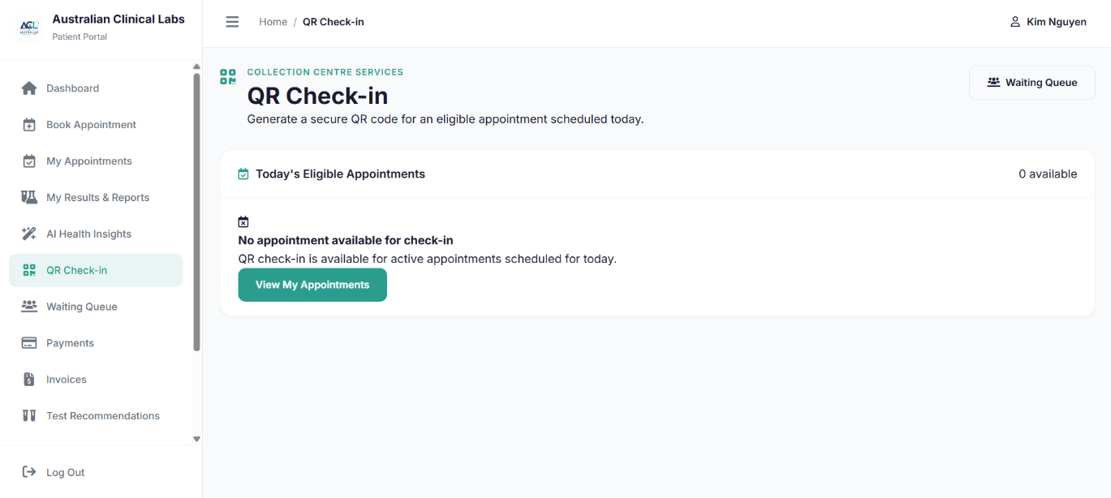
Source file: pages/patient/check-in.php
PHP controller: pages/patient/controllers/CheckInController.php
Purpose: Allows patients to check in for an eligible laboratory appointment scheduled for the current day using a secure QR code. The PHP controller retrieves eligible appointments, generates and validates the patient QR token, and manages the check-in process.
<?php
require_once __DIR__ . '/controllers/CheckInController.php';
?>

<?php

require_once __DIR__ . '/PatientSession.php.php';

$checkInMessage = '';
$checkInMessageType = '';
$todayAppointments = [];
$selectedAppointment = null;
$qrPayload = null;

function patientQrBase64UrlEncode(string $value): string
{
return rtrim(strtr(base64_encode($value), '+/', '-_'), '=');
}

function patientQrBase64UrlDecode(string $value): string|false
{
$padding = strlen($value) % 4;
if ($padding !== 0) {
$value .= str_repeat('=', 4 - $padding);
}
return base64_decode(strtr($value, '-_', '+/'), true);
}

function getPatientQrSecret(): string
{
if (empty($_SESSION['patient_qr_secret'])) {
$_SESSION['patient_qr_secret'] = bin2hex(random_bytes(32));
}
return (string) $_SESSION['patient_qr_secret'];
}

function buildPatientQrToken(int $patientId, int $appointmentId): string
{
$issuedAt = time();
$payload = $patientId . '|' . $appointmentId . '|' . $issuedAt;
$signature = hash_hmac('sha256', $payload, getPatientQrSecret());
return patientQrBase64UrlEncode($payload . '|' . $signature);
}

function validatePatientQrToken(string $token, int $patientId): ?int
{
$decoded = patientQrBase64UrlDecode($token);
if ($decoded === false) {
return null;
}

$parts = explode('|', $decoded);
if (count($parts) !== 4) {
return null;
}

[$tokenPatientId, $appointmentId, $issuedAt, $signature] = $parts;

if (!ctype_digit($tokenPatientId) || !ctype_digit($appointmentId) || !ctype_digit($issuedAt)) {
return null;
}

if ((int) $tokenPatientId !== $patientId) {
return null;
}

if (time() - (int) $issuedAt > 14400 || (int) $issuedAt > time() + 60) {
return null;
}

$payload = $tokenPatientId . '|' . $appointmentId . '|' . $issuedAt;
$expected = hash_hmac('sha256', $payload, getPatientQrSecret());

if (!hash_equals($expected, $signature)) {
return null;
}

return (int) $appointmentId;
}

function findCheckInAppointment(PDO $pdo, int $patientId, int $appointmentId): ?array
{
$stmt = $pdo->prepare(
"SELECT
a.appointment_id,
a.patient_id,
a.test_id,
a.appointment_datetime,
a.location,
a.appointment_status,
a.special_instructions,
tc.test_name,
tc.test_code
FROM appointments a
LEFT JOIN test_catalogue tc ON tc.test_id = a.test_id
WHERE a.appointment_id = :appointment_id
AND a.patient_id = :patient_id
AND DATE(a.appointment_datetime) = CURDATE()
AND a.appointment_status IN ('booked', 'confirmed', 'rescheduled')
LIMIT 1"
);
$stmt->execute([
':appointment_id' => $appointmentId,
':patient_id' => $patientId,
]);
$row = $stmt->fetch(PDO::FETCH_ASSOC);
return $row ?: null;
}

function storePatientCheckIn(array $appointment, int $patientId): void
{
$_SESSION['patient_checkin'] = [
'appointment_id' => (int) $appointment['appointment_id'],
'patient_id' => $patientId,
'location' => (string) ($appointment['location'] ?? ''),
'appointment_datetime' => (string) $appointment['appointment_datetime'],
'checked_in_at' => date('Y-m-d H:i:s'),
'status' => 'waiting',
];
}

try {
$stmt = $pdo->prepare(
"SELECT
a.appointment_id,
a.patient_id,
a.test_id,
a.appointment_datetime,
a.location,
a.appointment_status,
a.special_instructions,
tc.test_name,
tc.test_code
FROM appointments a
LEFT JOIN test_catalogue tc ON tc.test_id = a.test_id
WHERE a.patient_id = :patient_id
AND DATE(a.appointment_datetime) = CURDATE()
AND a.appointment_status IN ('booked', 'confirmed', 'rescheduled')
ORDER BY a.appointment_datetime ASC"
);
$stmt->execute([':patient_id' => $patientId]);
$todayAppointments = $stmt->fetchAll(PDO::FETCH_ASSOC);
} catch (PDOException $e) {
$checkInMessage = 'Unable to load today\'s appointments.';
$checkInMessageType = 'error';
}

if ($_SERVER['REQUEST_METHOD'] === 'POST') {
$action = (string) ($_POST['action'] ?? '');
$appointmentId = filter_input(INPUT_POST, 'appointment_id', FILTER_VALIDATE_INT);

if (in_array($action, ['generate_qr', 'check_in'], true)) {
if (!$appointmentId) {
$checkInMessage = 'Invalid appointment selected.';
$checkInMessageType = 'error';
} else {
$appointment = findCheckInAppointment($pdo, $patientId, (int) $appointmentId);

if (!$appointment) {
$checkInMessage = 'This appointment is not available for check-in.';
$checkInMessageType = 'error';
} elseif ($action === 'generate_qr') {
$token = buildPatientQrToken($patientId, (int) $appointmentId);
$_SESSION['patient_qr'] = [
'appointment_id' => (int) $appointmentId,
'token' => $token,
'generated_at' => time(),
];
header('Location: check-in.php?appointment=' . urlencode((string) $appointmentId));
exit;
} else {
storePatientCheckIn($appointment, $patientId);
header('Location: queue.php?checked_in=1');
exit;
}
}
}
}

if (!empty($_GET['token'])) {
$token = trim((string) $_GET['token']);
$appointmentId = validatePatientQrToken($token, $patientId);

if ($appointmentId !== null) {
$appointment = findCheckInAppointment($pdo, $patientId, $appointmentId);
if ($appointment) {
storePatientCheckIn($appointment, $patientId);
header('Location: queue.php?checked_in=1');
exit;
}
}

$checkInMessage = 'This QR code is invalid or has expired. Please generate a new QR code.';
$checkInMessageType = 'error';
}

$selectedAppointmentId = filter_input(INPUT_GET, 'appointment', FILTER_VALIDATE_INT);
if ($selectedAppointmentId) {
$selectedAppointment = findCheckInAppointment($pdo, $patientId, (int) $selectedAppointmentId);

if (
$selectedAppointment
&& isset($_SESSION['patient_qr'])
&& (int) ($_SESSION['patient_qr']['appointment_id'] ?? 0) === (int) $selectedAppointmentId
) {
$qrToken = (string) ($_SESSION['patient_qr']['token'] ?? '');
if ($qrToken !== '') {
$scheme = (!empty($_SERVER['HTTPS']) && $_SERVER['HTTPS'] !== 'off') ? 'https' : 'http';
$host = $_SERVER['HTTP_HOST'] ?? 'localhost';
$path = strtok($_SERVER['REQUEST_URI'] ?? '/pages/patient/check-in.php', '?');
$qrPayload = $scheme . '://' . $host . $path . '?token=' . rawurlencode($qrToken);
}
}
}
?>

PHP 11 — Waiting Queue
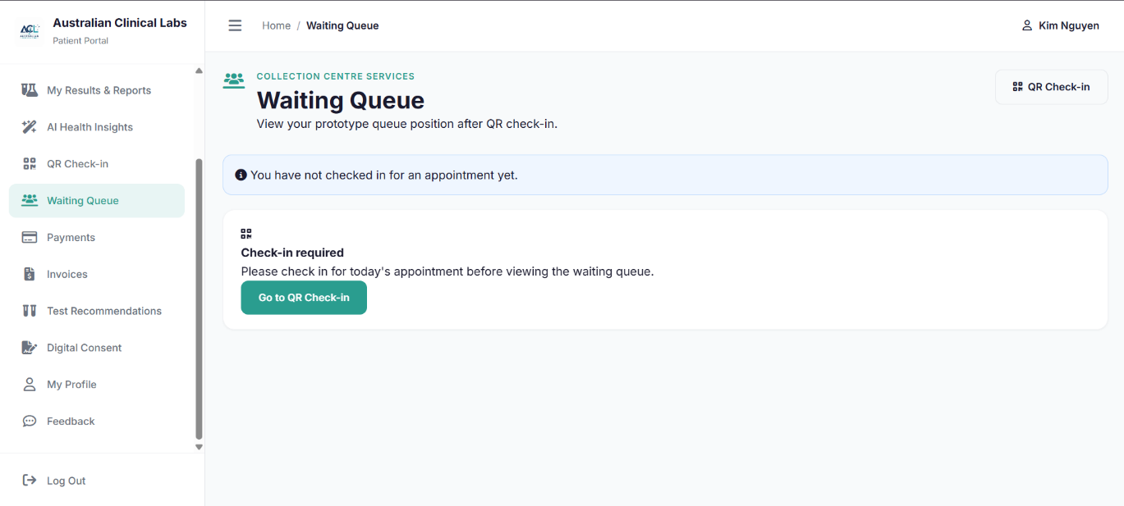
Source file: pages/patient/queue.php
PHP controller: pages/patient/controllers/QueueController.php
Purpose: Allows checked-in patients to view their current laboratory waiting queue information. The PHP controller validates the patient’s check-in session, retrieves the associated appointment information, and manages the patient’s queue status.
<?php
require_once __DIR__ . '/controllers/QueueController.php';
?>

<?php

require_once __DIR__ . '/PatientSession.php.php';

$queueData = null;
$queueMessage = '';
$queueMessageType = '';

if ($_SERVER['REQUEST_METHOD'] === 'POST' && ($_POST['action'] ?? '') === 'leave_queue') {
unset($_SESSION['patient_checkin'], $_SESSION['patient_qr']);
header('Location: check-in.php?left_queue=1');
exit;
}

if (empty($_SESSION['patient_checkin'])) {
$queueMessage = 'You have not checked in for an appointment yet.';
$queueMessageType = 'info';
return;
}

$checkin = $_SESSION['patient_checkin'];
$appointmentId = (int) ($checkin['appointment_id'] ?? 0);
$checkinPatientId = (int) ($checkin['patient_id'] ?? 0);

if ($appointmentId <= 0 || $checkinPatientId !== $patientId) {
unset($_SESSION['patient_checkin']);
$queueMessage = 'Your check-in session is no longer valid.';
$queueMessageType = 'error';
return;
}

try {
$stmt = $pdo->prepare(
"SELECT
a.appointment_id,
a.patient_id,
a.test_id,
a.appointment_datetime,
a.location,
a.appointment_status,
tc.test_name,
tc.test_code
FROM appointments a
LEFT JOIN test_catalogue tc ON tc.test_id = a.test_id
WHERE a.appointment_id = :appointment_id
AND a.patient_id = :patient_id
AND DATE(a.appointment_datetime) = CURDATE()
LIMIT 1"
);
$stmt->execute([
':appointment_id' => $appointmentId,
':patient_id' => $patientId,
]);
$appointment = $stmt->fetch(PDO::FETCH_ASSOC);

if (!$appointment) {
unset($_SESSION['patient_checkin']);
$queueMessage = 'The checked-in appointment could not be found.';
$queueMessageType = 'error';
return;
}

$locationValue = (string) ($appointment['location'] ?? '');

$aheadStmt = $pdo->prepare(
"SELECT COUNT(*)
FROM appointments
WHERE DATE(appointment_datetime) = DATE(:appointment_datetime)
AND COALESCE(location, '') = :location
AND appointment_status IN ('booked', 'confirmed', 'rescheduled')
AND appointment_datetime < :appointment_datetime"
);
$aheadStmt->execute([
':appointment_datetime' => $appointment['appointment_datetime'],
':location' => $locationValue,
]);
$patientsAhead = (int) $aheadStmt->fetchColumn();

$totalStmt = $pdo->prepare(
"SELECT COUNT(*)
FROM appointments
WHERE DATE(appointment_datetime) = DATE(:appointment_datetime)
AND COALESCE(location, '') = :location
AND appointment_status IN ('booked', 'confirmed', 'rescheduled')"
);
$totalStmt->execute([
':appointment_datetime' => $appointment['appointment_datetime'],
':location' => $locationValue,
]);
$totalQueue = max(1, (int) $totalStmt->fetchColumn());

$minutesPerPatient = 10;
$estimatedWait = $patientsAhead * $minutesPerPatient;

$queueData = [
'appointment_id' => $appointmentId,
'test_name' => (string) ($appointment['test_name'] ?? 'Laboratory Appointment'),
'queue_number' => $patientsAhead + 1,
'patients_ahead' => $patientsAhead,
'total_queue' => $totalQueue,
'estimated_wait' => $estimatedWait,
'location' => $locationValue !== '' ? $locationValue : 'Australian Clinical Labs',
'appointment_datetime' => (string) $appointment['appointment_datetime'],
'checked_in_at' => (string) ($checkin['checked_in_at'] ?? ''),
'status' => 'waiting',
'status_label' => $patientsAhead === 0 ? 'You are next' : 'Waiting',
];

if (isset($_GET['checked_in']) && $_GET['checked_in'] === '1') {
$queueMessage = 'Check-in successful. You have joined the waiting queue.';
$queueMessageType = 'success';
}
} catch (PDOException $e) {
$queueMessage = 'Unable to calculate the waiting queue at this time.';
$queueMessageType = 'error';
}
?>

PHP 12 — Payments
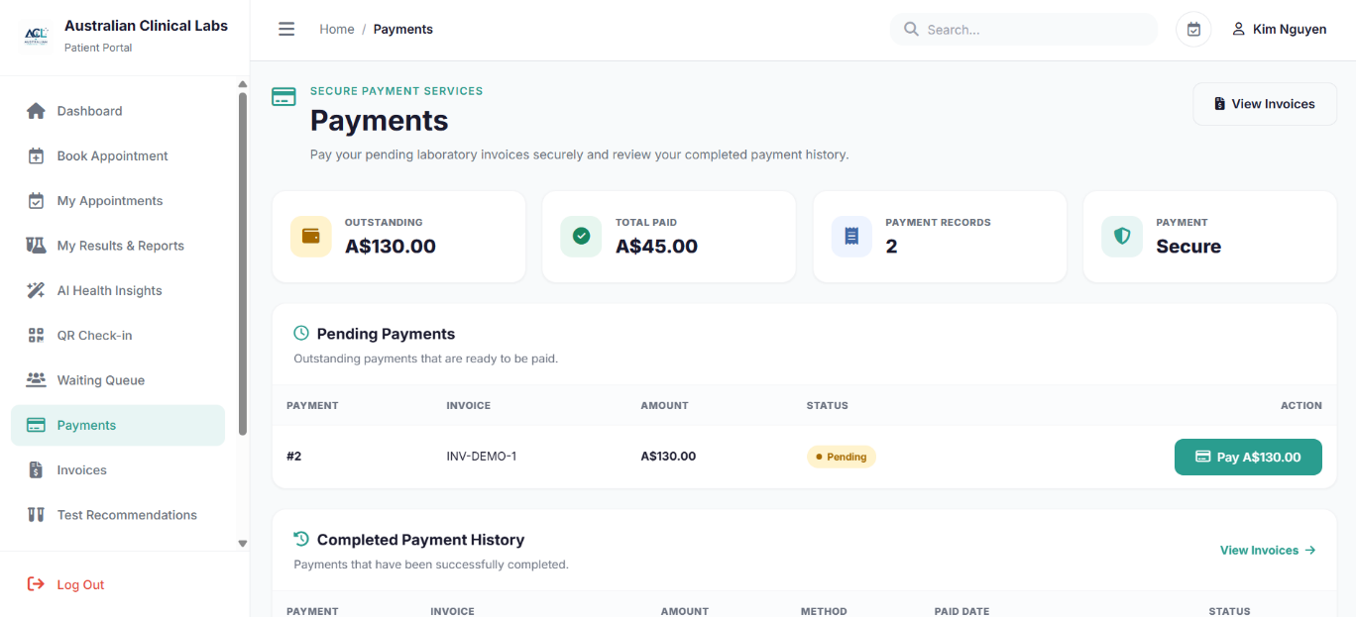
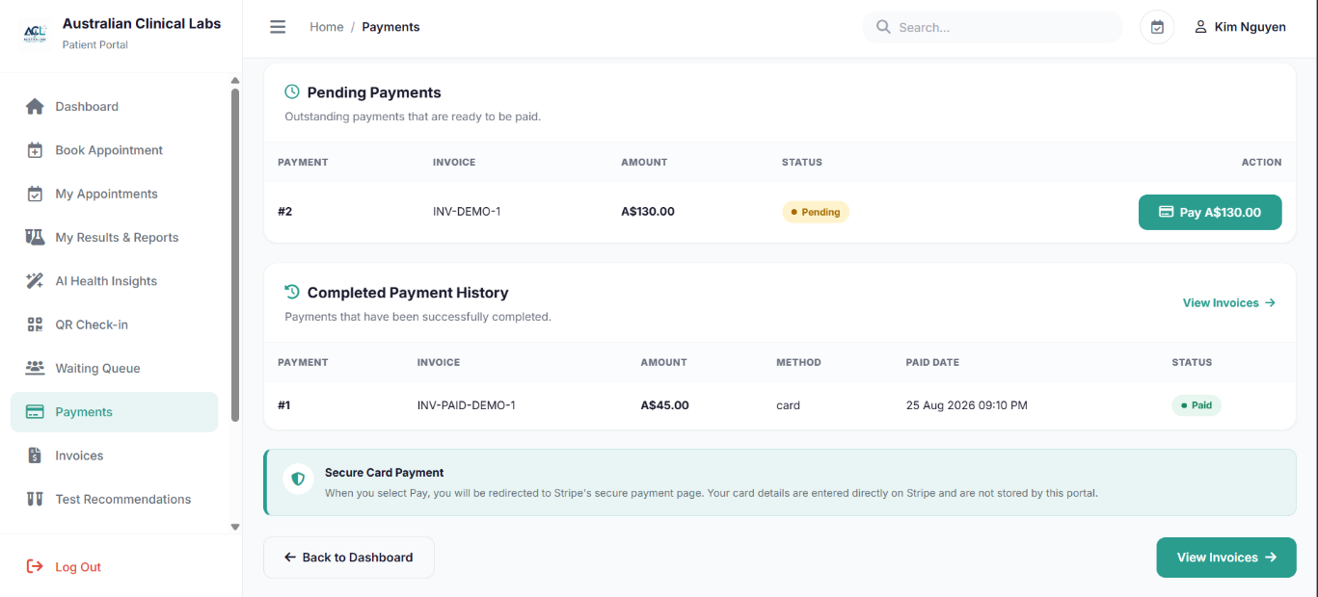
Source file: pages/patient/payments.php
PHP controller: pages/patient/controllers/PaymentController.php
Purpose: Allows patients to view and manage payments for their laboratory invoices through the patient portal. The PHP controller retrieves patient and invoice information and integrates the payment process with Stripe for eligible invoices.
<?php
require_once __DIR__ . '/controllers/PaymentController.php';
?>

<?php

define('STRIPE_SECRET_KEY', 'sk_test_51UCefH0bLUBXupskZjrGvcN2MnUHFcwKQuRJ3w9mtrzibewiS6BVFn84kxL6gTgxgWpL05DH4uFiHvJudbJ69RJA00EWW8tetF');

define('STRIPE_WEBHOOK_SECRET', 'pk_test_51UCefH0bLUBXupskqqUrYGVVRjGXpmrL3712c2YgRRRKiCEjGCdnVjY42McSpo4VOkDhHO80etygqpfqWCcy2o1S00tXks2cFO');

define('BASE_URL', 'http://localhost/AustraliaClinicalLabs');

require_once __DIR__ . '/PatientSession.php.php';

if (!isset($_SESSION['user_id'])) {
header('Location: ../auth/login.php?portal=patient');
exit;
}

$userId = (int) $_SESSION['user_id'];

$stmt = $pdo->prepare("
SELECT
patient_id,
user_id,
first_name,
last_name,
email,
phone_number
FROM patients
WHERE user_id = :user_id
LIMIT 1
");

$stmt->execute([
':user_id' => $userId
]);

$patient = $stmt->fetch(PDO::FETCH_ASSOC);

if (!$patient) {
session_destroy();
die('Patient not found.');
}

$patientId = (int) $patient['patient_id'];

$patientName = trim(
($patient['first_name'] ?? '') . ' ' .
($patient['last_name'] ?? '')
);

$paymentMessage = '';
$paymentMessageType = '';

if (($_GET['payment'] ?? '') === 'cancelled') {
$paymentMessage = 'Payment was cancelled. No payment was made.';
$paymentMessageType = 'error';
}

if (($_GET['payment'] ?? '') === 'success') {
$paymentMessage =
'Payment submitted successfully. Stripe has received the checkout. '
. 'The payment will appear as completed after the Stripe webhook confirms it.';
$paymentMessageType = 'success';
}

if (isset($_GET['payment_error'])) {
$paymentMessage = (string) $_GET['payment_error'];
$paymentMessageType = 'error';
}

if (
$_SERVER['REQUEST_METHOD'] === 'POST' &&
($_POST['action'] ?? '') === 'pay'
) {

$paymentId = filter_input(
INPUT_POST,
'payment_id',
FILTER_VALIDATE_INT
);

if (!$paymentId || $paymentId <= 0) {
header(
'Location: payments.php?payment_error=' .
rawurlencode('Invalid payment request.'),
true,
303
);
exit;
}

$stmt = $pdo->prepare("
SELECT
p.payment_id,
p.invoice_id,
p.amount,
p.payment_method,
p.payment_status,

i.patient_id,
i.invoice_number,
i.invoice_status,
i.total_amount

FROM payments p

INNER JOIN invoices i
ON i.invoice_id = p.invoice_id

WHERE p.payment_id = :payment_id
AND i.patient_id = :patient_id

LIMIT 1
");

$stmt->execute([
':payment_id' => $paymentId,
':patient_id' => $patientId
]);

$payment = $stmt->fetch(PDO::FETCH_ASSOC);

if (!$payment) {
header(
'Location: payments.php?payment_error=' .
rawurlencode('Payment record not found.'),
true,
303
);
exit;
}

$paymentStatus = strtolower(
trim($payment['payment_status'] ?? '')
);

$invoiceStatus = strtolower(
trim($payment['invoice_status'] ?? '')
);

$amount = (float) ($payment['amount'] ?? 0);

if ($paymentStatus !== 'pending') {

$message =
$paymentStatus === 'successful'
? 'This payment has already been completed.'
: 'This payment is no longer available for payment.';

header(
'Location: payments.php?payment_error=' .
rawurlencode($message),
true,
303
);
exit;
}

if (
in_array(
$invoiceStatus,
['paid', 'cancelled', 'refunded'],
true
)
) {
header(
'Location: payments.php?payment_error=' .
rawurlencode('This invoice is not available for payment.'),
true,
303
);
exit;
}

if ($amount <= 0) {
header(
'Location: payments.php?payment_error=' .
rawurlencode('Invalid payment amount.'),
true,
303
);
exit;
}

$stripeSecretKey = getenv('STRIPE_SECRET_KEY');

if (
!$stripeSecretKey &&
defined('STRIPE_SECRET_KEY')
) {
$stripeSecretKey = STRIPE_SECRET_KEY;
}

if (!$stripeSecretKey) {
header(
'Location: payments.php?payment_error=' .
rawurlencode(
'Stripe is not configured. Please add your Stripe TEST secret key as STRIPE_SECRET_KEY.'
),
true,
303
);
exit;
}

if (!function_exists('curl_init')) {
header(
'Location: payments.php?payment_error=' .
rawurlencode(
'PHP cURL is not enabled. Enable cURL in XAMPP.'
),
true,
303
);
exit;
}

$baseUrl = getenv('BASE_URL');

if (
!$baseUrl &&
defined('BASE_URL')
) {
$baseUrl = BASE_URL;
}

if (!$baseUrl) {
$baseUrl = 'http://localhost/Kim/patient_portal';
}

$baseUrl = rtrim($baseUrl, '/');

$amountInCents = (int) round(
$amount * 100
);

$invoiceId = (int) $payment['invoice_id'];

$invoiceNumber =
$payment['invoice_number']
?: $invoiceId;
$requestScheme = (!empty($_SERVER['HTTPS']) && $_SERVER['HTTPS'] !== 'off') ? 'https' : 'http';
$requestHost = $_SERVER['HTTP_HOST'] ?? 'localhost';
$patientPath = rtrim(str_replace('\\', '/', dirname($_SERVER['SCRIPT_NAME'] ?? '/pages/patient/payments.php')), '/');
$patientBaseUrl = $requestScheme . '://' . $requestHost . $patientPath;

$successUrl =
$patientBaseUrl .
'/payments.php?payment=success&session_id={CHECKOUT_SESSION_ID}';

$cancelUrl =
$patientBaseUrl .
'/payments.php?payment=cancelled';

$stripeData = [

'mode' => 'payment',

'success_url' =>
$successUrl,

'cancel_url' =>
$cancelUrl,

'customer_email' =>
$patient['email'] ?? '',

'client_reference_id' =>
(string) $paymentId,

/*
| AUD amount
*/

'line_items[0][price_data][currency]' =>
'aud',

'line_items[0][price_data][product_data][name]' =>
'Australian Clinical Labs - Invoice #' .
$invoiceNumber,

'line_items[0][price_data][product_data][description]' =>
'Australian Clinical Labs laboratory services',

'line_items[0][price_data][unit_amount]' =>
$amountInCents,

'line_items[0][quantity]' =>
1,

/*
| Metadata for Stripe webhook
*/

'metadata[payment_id]' =>
(string) $paymentId,

'metadata[patient_id]' =>
(string) $patientId,

'metadata[invoice_id]' =>
(string) $invoiceId
];

$ch = curl_init(
'https://api.stripe.com/v1/checkout/sessions'
);

curl_setopt_array(
$ch,
[
CURLOPT_POST => true,

CURLOPT_POSTFIELDS =>
http_build_query($stripeData),

CURLOPT_RETURNTRANSFER => true,

CURLOPT_TIMEOUT => 30,

CURLOPT_HTTPHEADER => [
'Authorization: Bearer ' .
$stripeSecretKey,

'Content-Type: application/x-www-form-urlencoded'
]
]
);

$response = curl_exec($ch);

$curlError = curl_error($ch);

$httpCode = curl_getinfo(
$ch,
CURLINFO_HTTP_CODE
);

curl_close($ch);

if (
$response === false ||
$curlError !== ''
) {

header(
'Location: payments.php?payment_error=' .
rawurlencode(
'Unable to connect to Stripe: ' . $curlError
),
true,
303
);
exit;
}

$stripeSession = json_decode(
$response,
true
);

if (
$httpCode >= 200 &&
$httpCode < 300 &&
!empty($stripeSession['url'])
) {

header(
'Location: ' .
$stripeSession['url'],
true,
303
);

exit;
}

$stripeError =
$stripeSession['error']['message']
??
'Unable to start the Stripe payment process.';

header(
'Location: payments.php?payment_error=' .
rawurlencode(
'Stripe error: ' . $stripeError
),
true,
303
);

exit;
}

$stmt = $pdo->prepare("
INSERT INTO payments
(invoice_id, amount, payment_method, payment_status)
SELECT
i.invoice_id,
i.total_amount,
'card',
'pending'
FROM invoices i
WHERE i.patient_id = :patient_id
AND LOWER(TRIM(i.invoice_status)) IN ('issued', 'partially_paid', 'overdue')
AND i.total_amount > 0
AND NOT EXISTS (
SELECT 1
FROM payments existing_payment
WHERE existing_payment.invoice_id = i.invoice_id
AND LOWER(TRIM(existing_payment.payment_status)) IN ('pending', 'successful')
)
");

$stmt->execute([
':patient_id' => $patientId
]);

$stmt = $pdo->prepare("
SELECT
p.payment_id,
p.invoice_id,
p.amount,
p.payment_method,
p.payment_status,
p.transaction_reference,
p.paid_at,
p.created_at,

i.invoice_number,
i.invoice_status

FROM payments p

INNER JOIN invoices i
ON i.invoice_id = p.invoice_id

WHERE i.patient_id = :patient_id

ORDER BY
CASE
WHEN p.payment_status = 'pending' THEN 1
WHEN p.payment_status = 'failed' THEN 2
WHEN p.payment_status = 'successful' THEN 3
WHEN p.payment_status = 'refunded' THEN 4
WHEN p.payment_status = 'partially_refunded' THEN 5
ELSE 6
END,

p.created_at DESC,
p.payment_id DESC
");

$stmt->execute([
':patient_id' => $patientId
]);

$payments = $stmt->fetchAll(PDO::FETCH_ASSOC);

$totalOutstanding = 0.00;
$totalPaid = 0.00;

foreach ($payments as $payment) {

$amount = (float) (
$payment['amount'] ?? 0
);

$status = strtolower(
trim($payment['payment_status'] ?? '')
);

if ($status === 'successful') {

$totalPaid += $amount;

} elseif ($status === 'pending') {

$totalOutstanding += $amount;
}
}
?>

PHP 13 — Invoices
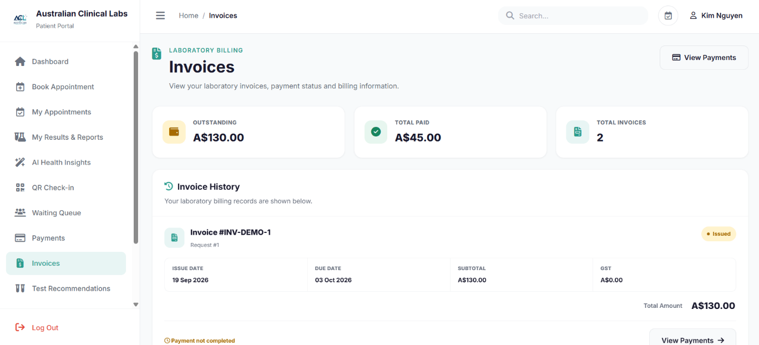
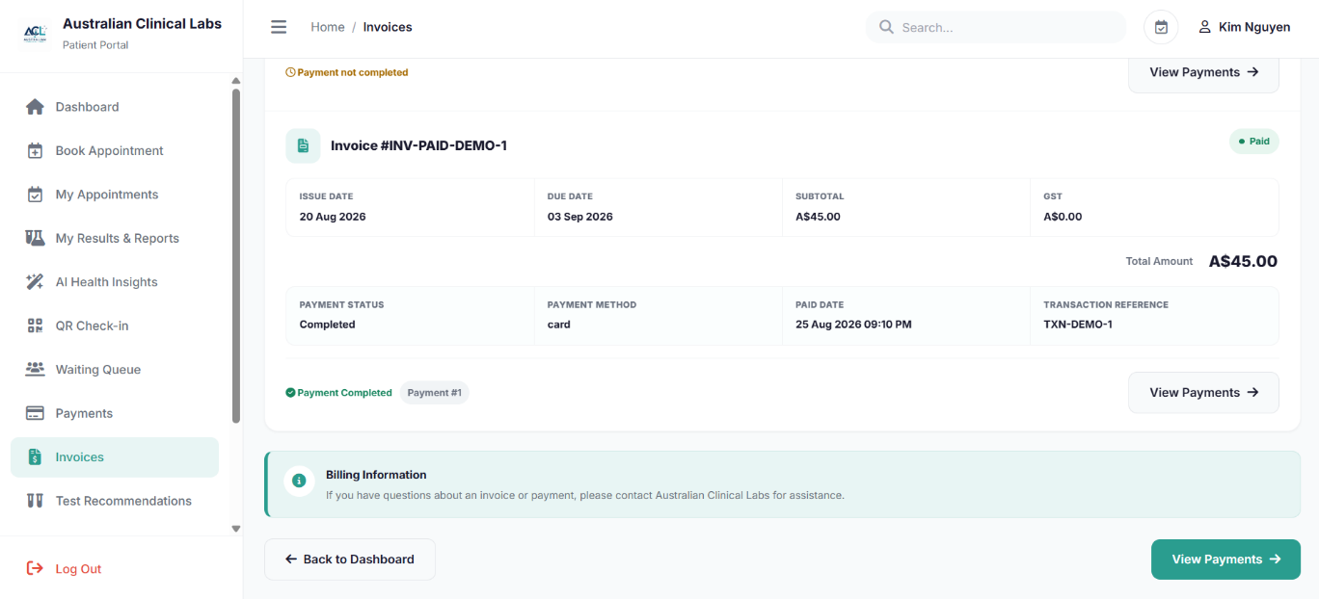
Source file: pages/patient/invoices.php
PHP controller: pages/patient/controllers/InvoiceController.php
Purpose: Allows patients to view their laboratory invoice history and associated billing information. The PHP controller retrieves patient-specific invoices and displays the latest successful payment information associated with each invoice.
<?php
require_once __DIR__ . '/controllers/InvoiceController.php';
?>

<?php

require_once __DIR__ . '/PatientSession.php.php';

if (!isset($_SESSION['user_id'])) {
header('Location: ../auth/login.php?portal=patient');
exit;
}

$userId = (int) $_SESSION['user_id'];

$stmt = $pdo->prepare("
SELECT patient_id, user_id, patient_identifier, first_name, last_name,
date_of_birth, gender, phone_number, email, medicare_number
FROM patients
WHERE user_id = :user_id
LIMIT 1
");
$stmt->execute([':user_id' => $userId]);

$patient = $stmt->fetch(PDO::FETCH_ASSOC);

if (!$patient) {
session_destroy();
die('Patient account not found. Please sign in with a valid patient account.');
}

$patientId = (int) $patient['patient_id'];
$patientName = trim(($patient['first_name'] ?? '') . ' ' . ($patient['last_name'] ?? ''));

$stmt = $pdo->prepare("
SELECT
i.invoice_id,
i.request_id,
i.patient_id,
i.invoice_number,
i.issue_date,
i.due_date,
i.subtotal,
i.gst_amount,
i.total_amount,
i.invoice_status,

p.payment_id AS completed_payment_id,
p.amount AS completed_payment_amount,
p.payment_method AS completed_payment_method,
p.transaction_reference AS completed_transaction_reference,
p.paid_at AS completed_paid_at

FROM invoices i

LEFT JOIN payments p
ON p.payment_id = (
SELECT p2.payment_id
FROM payments p2
WHERE p2.invoice_id = i.invoice_id
AND p2.payment_status = 'successful'
ORDER BY p2.paid_at DESC, p2.payment_id DESC
LIMIT 1
)

WHERE i.patient_id = :patient_id

ORDER BY i.issue_date DESC, i.invoice_id DESC
");

$stmt->execute([':patient_id' => $patientId]);
$invoices = $stmt->fetchAll(PDO::FETCH_ASSOC);

$totalOutstanding = 0.00;
$totalPaid = 0.00;
$totalInvoices = count($invoices);

foreach ($invoices as $invoice) {
$amount = (float) ($invoice['total_amount'] ?? 0);
$status = strtolower(trim($invoice['invoice_status'] ?? ''));

if ($status === 'paid') {
$totalPaid += $amount;
} elseif (!in_array($status, ['cancelled', 'refunded'], true)) {
$totalOutstanding += $amount;
}
}
?>

PHP 14 — Test Recommendations
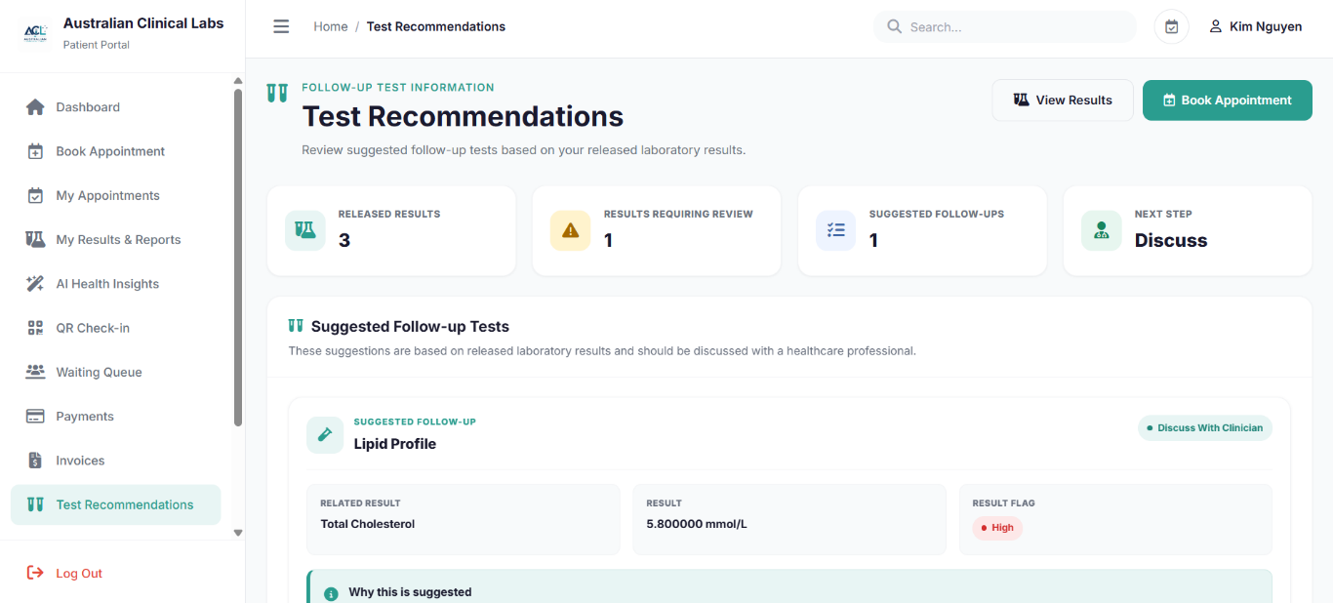
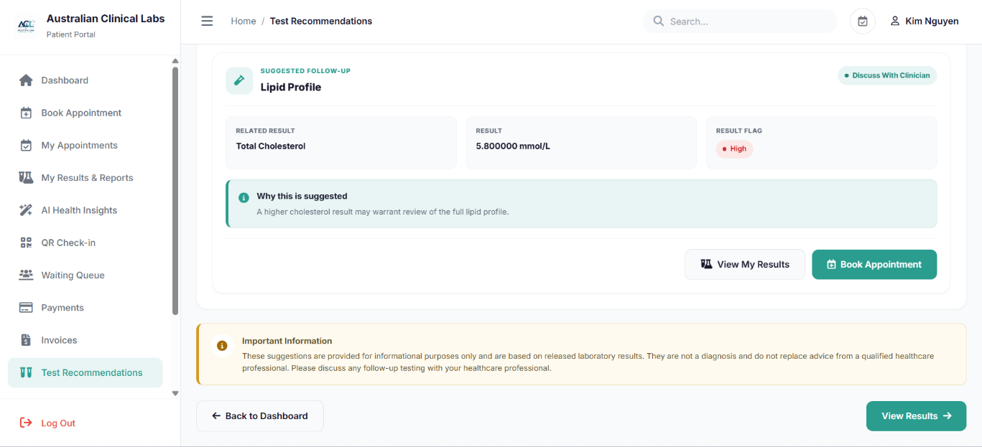
Source file: pages/patient/recommendations.php
PHP controller: pages/patient/controllers/RecommendationController.php
Purpose: Provides follow-up laboratory test recommendations based on the patient’s available results. The PHP controller retrieves the patient's recent laboratory information and identifies relevant result information used to present follow-up test recommendations.
<?php
require_once __DIR__ . '/controllers/RecommendationController.php';
?>

<?php

require_once __DIR__ . '/PatientSession.php.php';

$userId = isset($_SESSION['user_id']) ? (int) $_SESSION['user_id'] : 0;

if ($userId <= 0) {
header('Location: ../auth/login.php?portal=patient');
exit;
}

$stmt = $pdo->prepare("
SELECT
patient_id,
user_id,
first_name,
last_name,
email,
phone_number
FROM patients
WHERE user_id = :user_id
LIMIT 1
");

$stmt->execute([
':user_id' => $userId
]);

$patient = $stmt->fetch(PDO::FETCH_ASSOC);

if (!$patient) {
die('Patient not found.');
}

$patientId = (int) $patient['patient_id'];

$patientName = trim(
($patient['first_name'] ?? '') . ' ' .
($patient['last_name'] ?? '')
);

$recommendations = [];

$recentResults = [];

$totalResults = 0;

$abnormalResults = 0;

$stmt = $pdo->prepare("
SELECT
tr.result_id,

tr.result_numeric,

tr.result_text,

tr.unit AS result_unit,

tr.result_flag,

tp.parameter_id,

tp.parameter_name,

tp.unit AS parameter_unit,

tp.reference_low,

tp.reference_high,

tp.test_id,

lr.report_id,

lr.report_date,

lr.report_status,

req.request_id,

req.patient_id

FROM test_results tr

INNER JOIN test_parameters tp
ON tr.parameter_id = tp.parameter_id

INNER JOIN report_results rr
ON tr.result_id = rr.result_id

INNER JOIN lab_reports lr
ON rr.report_id = lr.report_id

INNER JOIN test_requests req
ON lr.request_id = req.request_id

WHERE req.patient_id = :patient_id
AND lr.report_status = 'final'

ORDER BY
lr.report_date DESC,
tr.result_id DESC
");

$stmt->execute([
':patient_id' => $patientId
]);

$recentResults =
$stmt->fetchAll(PDO::FETCH_ASSOC);

$totalResults =
count($recentResults);

foreach ($recentResults as $result) {

$parameterName =
trim(
$result['parameter_name'] ?? ''
);

$flag =
strtolower(
trim(
$result['result_flag'] ?? ''
)
);

$numericValue =
$result['result_numeric'];

$referenceLow =
($result['reference_low'] ?? null);

$referenceHigh =
($result['reference_high'] ?? null);

$isAbnormal = false;

if (
in_array(
$flag,
[
'high',
'low',
'abnormal',
'critical_low',
'critical_high'
],
true
)
) {

$isAbnormal = true;

} elseif (
$numericValue !== null &&
$referenceLow !== null &&
$referenceHigh !== null
) {

if (
(float) $numericValue <
(float) $referenceLow
) {

$isAbnormal = true;

} elseif (
(float) $numericValue >
(float) $referenceHigh
) {

$isAbnormal = true;
}
}

if (!$isAbnormal) {
continue;
}

$abnormalResults++;

$recommendation = null;

if (
stripos(
$parameterName,
'haemoglobin'
) !== false ||
stripos(
$parameterName,
'hemoglobin'
) !== false
) {

if ($flag === 'low') {

$recommendation = [

'test' =>
'Full Blood Count (FBC)',

'reason' =>
'A low haemoglobin result may warrant further review of blood-cell measurements.',

'priority' =>
'Discuss with clinician'

];

} elseif ($flag === 'high') {

$recommendation = [

'test' =>
'Full Blood Count (FBC)',

'reason' =>
'A higher-than-reference haemoglobin result may require review together with other blood-cell measurements.',

'priority' =>
'Discuss with clinician'
];
}
}

elseif (
stripos(
$parameterName,
'glucose'
) !== false
) {

if (
$flag === 'high'
) {

$recommendation = [

'test' =>
'HbA1c',

'reason' =>
'A high glucose result may require further assessment of longer-term blood glucose levels.',

'priority' =>
'Discuss with clinician'
];
}
}

elseif (
stripos(
$parameterName,
'cholesterol'
) !== false
) {

if (
$flag === 'high'
) {

$recommendation = [

'test' =>
'Lipid Profile',

'reason' =>
'A higher cholesterol result may warrant review of the full lipid profile.',

'priority' =>
'Discuss with clinician'
];
}
}

elseif (
stripos(
$parameterName,
'ferritin'
) !== false ||
stripos(
$parameterName,
'iron'
) !== false
) {

if (
$flag === 'low'
) {

$recommendation = [

'test' =>
'Iron Studies',

'reason' =>
'A low iron-related result may require review of additional iron measurements.',

'priority' =>
'Discuss with clinician'
];
}
}

elseif (
stripos(
$parameterName,
'vitamin b12'
) !== false ||
stripos(
$parameterName,
'b12'
) !== false
) {

if (
$flag === 'low'
) {

$recommendation = [

'test' =>
'Vitamin B12 / Folate Review',

'reason' =>
'A low vitamin B12 result may require further assessment of related nutritional markers.',

'priority' =>
'Discuss with clinician'
];
}
}

elseif (
stripos(
$parameterName,
'vitamin d'
) !== false
) {

if (
$flag === 'low'
) {

$recommendation = [

'test' =>
'Vitamin D Follow-up',

'reason' =>
'A low vitamin D result may require clinical review and consideration of follow-up testing.',

'priority' =>
'Discuss with clinician'
];
}
}

elseif (
stripos(
$parameterName,
'tsh'
) !== false ||
stripos(
$parameterName,
'thyroid'
) !== false
) {

$recommendation = [

'test' =>
'Thyroid Function Tests',

'reason' =>
'An abnormal thyroid-related result may require review with additional thyroid measurements.',

'priority' =>
'Discuss with clinician'
];
}

else {

$recommendation = [

'test' =>
'Clinical Review',

'reason' =>
'This result is outside the provided reference range and may require review by a qualified healthcare professional.',

'priority' =>
'Discuss with clinician'
];
}

if ($recommendation !== null) {

$recommendation['result_id'] =
$result['result_id'];

$recommendation['parameter_name'] =
$parameterName;

$recommendation['result_numeric'] =
$numericValue;

$recommendation['result_text'] =
$result['result_text'];

$recommendation['unit'] =
$result['parameter_unit']
?: $result['result_unit'];

$recommendation['result_flag'] =
$result['result_flag'];

$recommendation['report_date'] =
$result['report_date'];

$recommendations[] =
$recommendation;
}
}

$uniqueRecommendations = [];

foreach ($recommendations as $recommendation) {

$key =
$recommendation['test'] .
'|' .
$recommendation['parameter_name'];

if (
!isset(
$uniqueRecommendations[$key]
)
) {

$uniqueRecommendations[$key] =
$recommendation;
}
}

$recommendations =
array_values(
$uniqueRecommendations
);

$totalRecommendations =
count($recommendations);

?>

PHP 15 — Digital Consent
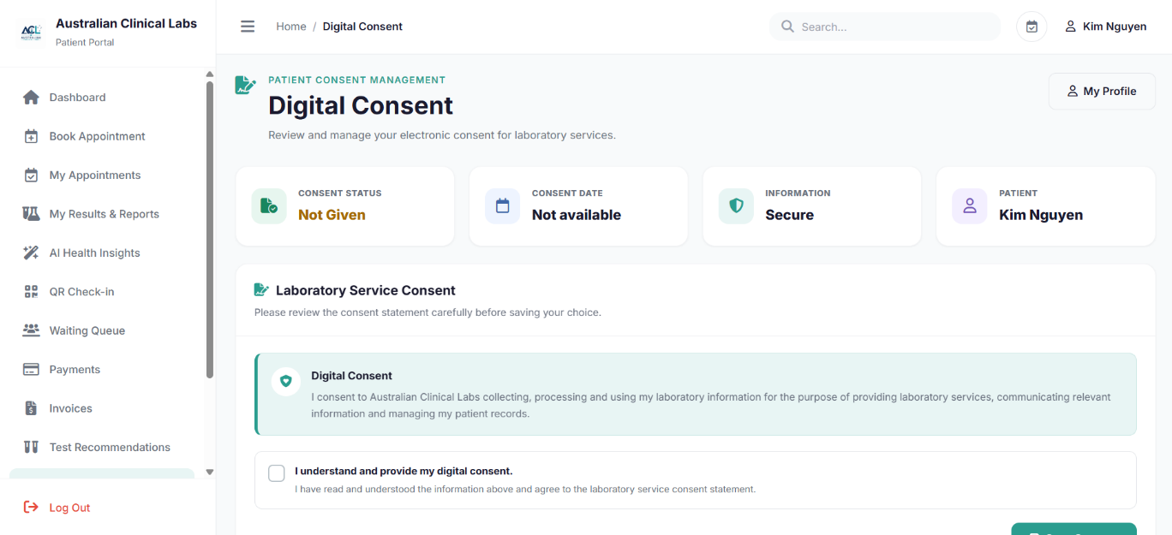
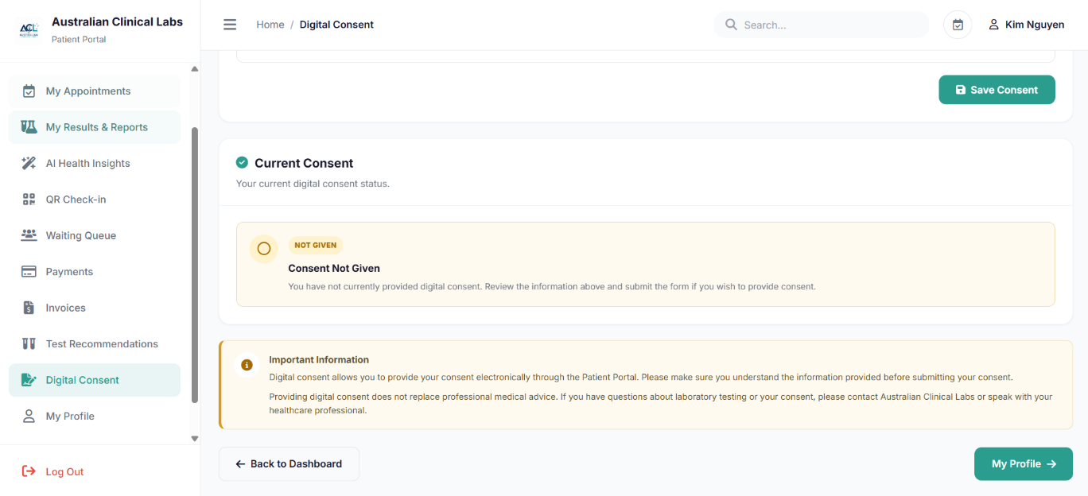
Source file: pages/patient/consent.php
PHP controller: pages/patient/controllers/ConsentController.php
Purpose: Allows patients to view, provide or withdraw their digital consent through the patient portal. The PHP controller retrieves the patient’s current consent status and records changes to the patient consent information in the database.
<?php
require_once __DIR__ . '/controllers/ConsentController.php';
?>

<?php

require_once __DIR__ . '/PatientSession.php.php';

$db = $pdo;
$consent = null;
$message = '';
$messageType = '';
$consentType = 'patient_portal_digital_consent';
$documentVersion = '1.0';

function loadCurrentConsent(PDO $db, int $patientId, string $consentType): ?array
{
$stmt = $db->prepare("\n SELECT\n consent_id, patient_id, consent_type, consent_status,\n CASE WHEN consent_status = 'granted' THEN 1 ELSE 0 END AS consent_given,\n consented_at AS consent_date, withdrawn_at, created_at\n FROM patient_consents\n WHERE patient_id = :patient_id\n AND consent_type = :consent_type\n ORDER BY consented_at DESC, consent_id DESC\n LIMIT 1\n ");
$stmt->execute([
':patient_id' => $patientId,
':consent_type' => $consentType
]);
$row = $stmt->fetch(PDO::FETCH_ASSOC);
return $row ?: null;
}

try {
$consent = loadCurrentConsent($db, $patientId, $consentType);
} catch (PDOException $e) {
$message = 'Unable to load your consent information.';
$messageType = 'error';
}

if ($_SERVER['REQUEST_METHOD'] === 'POST') {
$consentGiven = isset($_POST['consent_given']);
try {
$stmt = $db->prepare("\n INSERT INTO patient_consents (\n patient_id, recorded_by_user_id, consent_type, consent_status,\n signature_data, document_version, ip_address, consented_at, withdrawn_at\n ) VALUES (\n :patient_id, :user_id, :consent_type, :consent_status,\n NULL, :document_version, :ip_address, NOW(), :withdrawn_at\n )\n ");
$stmt->execute([
':patient_id' => $patientId,
':user_id' => $userId,
':consent_type' => $consentType,
':consent_status' => $consentGiven ? 'granted' : 'withdrawn',
':document_version' => $documentVersion,
':ip_address' => $_SERVER['REMOTE_ADDR'] ?? null,
':withdrawn_at' => $consentGiven ? null : date('Y-m-d H:i:s')
]);
$message = $consentGiven
? 'Your digital consent has been recorded successfully.'
: 'Your digital consent has been withdrawn.';
$messageType = 'success';
$consent = loadCurrentConsent($db, $patientId, $consentType);
} catch (PDOException $e) {
$message = 'Unable to update your digital consent.';
$messageType = 'error';
}
}
?>

PHP 16 — My Profile
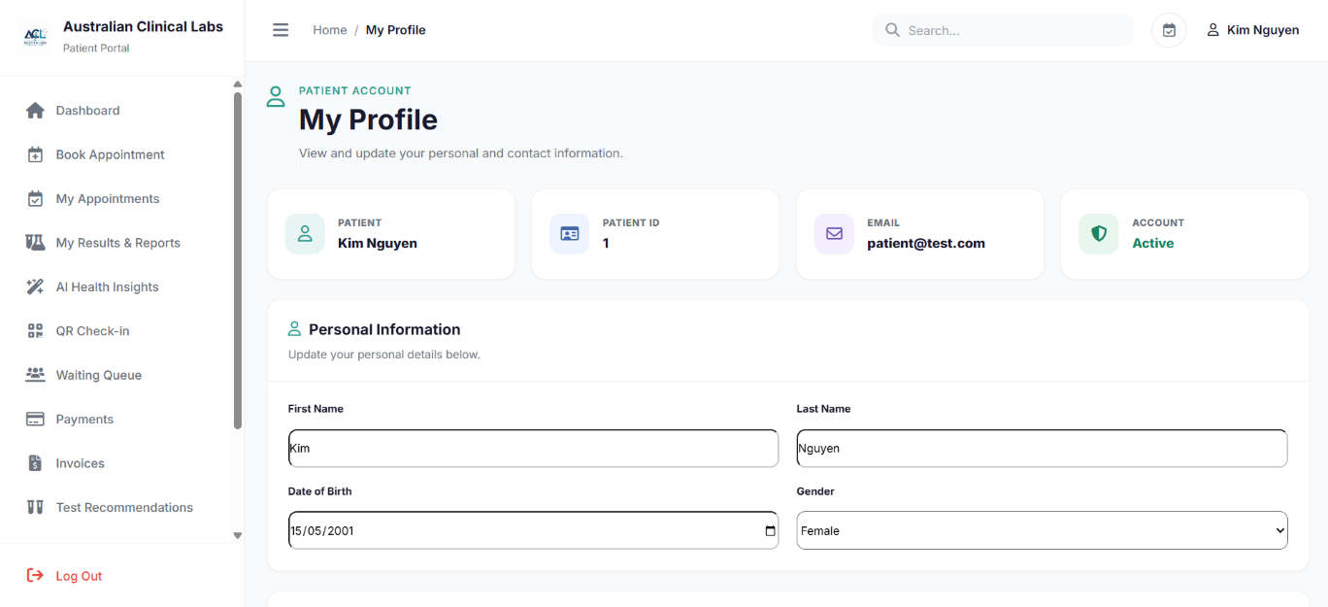
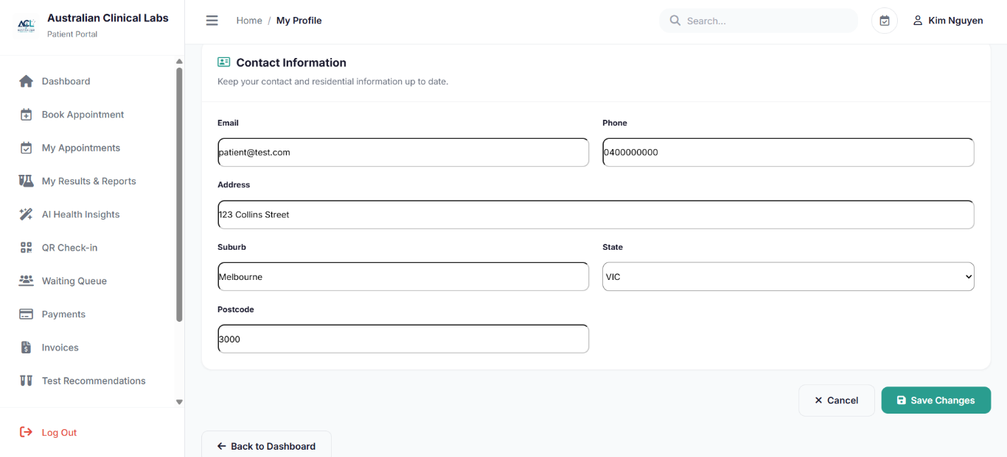
Source file: pages/patient/profile.php
PHP controller: pages/patient/controllers/ProfileController.php
Purpose: Allows patients to view and manage their personal account and profile information. The PHP controller retrieves the authenticated patient’s information from the database and processes supported updates to the patient profile.
<?php
require_once __DIR__ . '/controllers/ProfileController.php';

$fullName = trim(
($patient['first_name'] ?? '') . ' ' .
($patient['last_name'] ?? '')
);

if ($fullName === '') {
$fullName = $patientName ?? 'Patient';
}
?>

<?php

require_once __DIR__ . '/PatientSession.php.php';

if (!isset($_SESSION['user_id'])) {
header('Location: ../auth/login.php?portal=patient');
exit;
}

$userId = $_SESSION['user_id'];

$db = $pdo;

$patient = null;
$patientId = null;
$patientName = $_SESSION['user_name'] ?? 'Patient';

$message = '';
$messageType = '';

try {

$sql = "
SELECT *
FROM patients
WHERE user_id = :user_id

LIMIT 1
";

$stmt = $db->prepare($sql);

$stmt->execute([
':user_id' => $userId
]);

$patient = $stmt->fetch(PDO::FETCH_ASSOC);

if (!$patient) {
die('Patient record not found.');
}

$patientId = $patient['patient_id'];

$patientName = trim(
($patient['first_name'] ?? '') . ' ' .
($patient['last_name'] ?? '')
);

$patient['phone'] = $patient['phone_number'] ?? '';

} catch (PDOException $e) {

$message = 'Unable to load your profile information.';
$messageType = 'error';
}

if ($_SERVER['REQUEST_METHOD'] === 'POST') {

$firstName = trim($_POST['first_name'] ?? '');
$lastName = trim($_POST['last_name'] ?? '');
$dateOfBirth = $_POST['date_of_birth'] ?? '';
$gender = trim($_POST['gender'] ?? '');
$email = trim($_POST['email'] ?? '');
$phone = trim($_POST['phone'] ?? '');
$address = trim($_POST['address'] ?? '');
$suburb = trim($_POST['suburb'] ?? '');
$state = trim($_POST['state'] ?? '');
$postcode = trim($_POST['postcode'] ?? '');

try {

$sql = "
UPDATE patients
SET
first_name = :first_name,
last_name = :last_name,
date_of_birth = :date_of_birth,
gender = :gender,
email = :email,
phone_number = :phone,
address = :address,
suburb = :suburb,
state = :state,
postcode = :postcode
WHERE patient_id = :patient_id
AND user_id = :user_id
";

$stmt = $db->prepare($sql);

$stmt->execute([
':first_name' => $firstName,
':last_name' => $lastName,
':date_of_birth' => $dateOfBirth,
':gender' => $gender,
':email' => $email,
':phone' => $phone,
':address' => $address,
':suburb' => $suburb,
':state' => $state,
':postcode' => $postcode,
':patient_id' => $patientId,
':user_id' => $userId
]);

$message = 'Your profile has been updated successfully.';
$messageType = 'success';

$sql = "
SELECT
p.*
FROM patients p
WHERE p.user_id = :user_id
LIMIT 1
";

$stmt = $db->prepare($sql);

$stmt->execute([
':user_id' => $userId
]);

$patient = $stmt->fetch(PDO::FETCH_ASSOC);

if (!$patient) {
throw new RuntimeException('Patient record not found after update.');
}

$patientId = $patient['patient_id'];
$patient['phone'] = $patient['phone_number'] ?? '';

$patientName = trim(
($patient['first_name'] ?? '') . ' ' .
($patient['last_name'] ?? '')
);

} catch (PDOException $e) {

$message = 'Unable to update your profile. Please check the database fields.';
$messageType = 'error';

}

}
?>

PHP 17 — Feedback
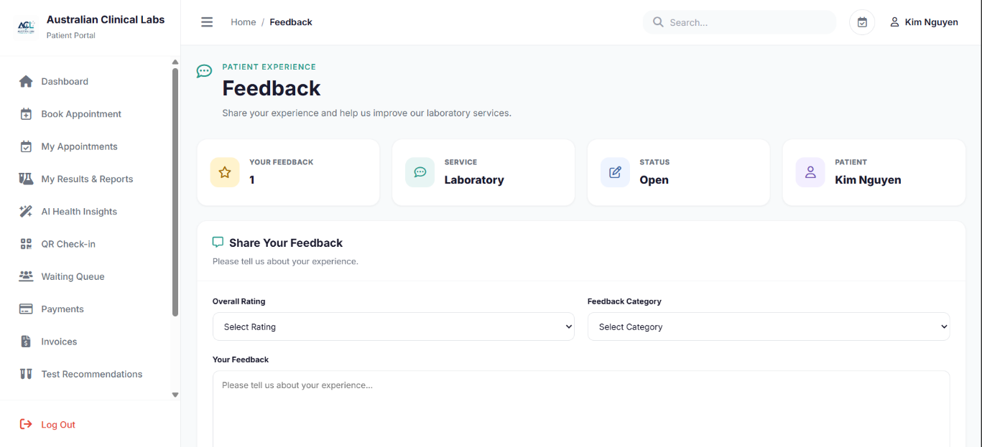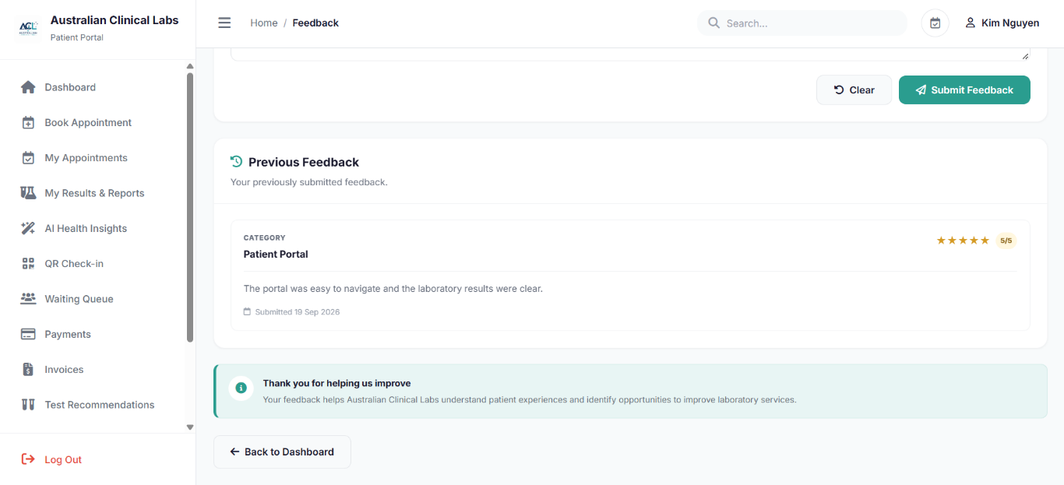
Source file: pages/patient/feedback.php
PHP controller: pages/patient/controllers/FeedbackController.php
Purpose: Allows patients to submit feedback about their experience and view their feedback information. The PHP controller identifies the authenticated patient, processes submitted feedback and retrieves the patient’s feedback history.
<?php
require_once __DIR__ . '/controllers/FeedbackController.php';
?>

<?php

require_once __DIR__ . '/PatientSession.php.php';

if (!isset($_SESSION['user_id'])) {
header('Location: ../auth/login.php?portal=patient');
exit;
}

$userId = $_SESSION['user_id'];

$db = $pdo;

$patient = null;
$patientId = null;
$patientName = $_SESSION['user_name'] ?? 'Patient';

$message = '';
$messageType = '';

$feedbackHistory = [];

try {

$sql = "
SELECT *
FROM patients
WHERE user_id = :user_id
LIMIT 1
";

$stmt = $db->prepare($sql);

$stmt->execute([
':user_id' => $userId
]);

$patient = $stmt->fetch(PDO::FETCH_ASSOC);

if (!$patient) {
die('Patient record not found.');
}

$patientId = $patient['patient_id'];

$patientName = trim(
($patient['first_name'] ?? '') . ' ' .
($patient['last_name'] ?? '')
);

} catch (PDOException $e) {

$message = 'Unable to load your patient information.';
$messageType = 'error';
}

if ($_SERVER['REQUEST_METHOD'] === 'POST') {

$rating = (int) ($_POST['rating'] ?? 0);
$category = trim($_POST['category'] ?? '');
$comments = trim($_POST['comments'] ?? '');

if ($rating < 1 || $rating > 5) {

$message = 'Please select a rating between 1 and 5.';
$messageType = 'error';

} elseif (empty($category)) {

$message = 'Please select a feedback category.';
$messageType = 'error';

} elseif (empty($comments)) {

$message = 'Please enter your feedback.';
$messageType = 'error';

} else {

try {

$sql = "
INSERT INTO patient_feedback
(
patient_id,
rating,
feedback_type,
comments,
submitted_at
)
VALUES
(
:patient_id,
:rating,
:category,
:comments,
NOW()
)
";

$stmt = $db->prepare($sql);

$stmt->execute([
':patient_id' => $patientId,
':rating' => $rating,
':category' => $category,
':comments' => $comments
]);

$message = 'Thank you. Your feedback has been submitted successfully.';
$messageType = 'success';

} catch (PDOException $e) {

$message = 'Unable to submit your feedback.';
$messageType = 'error';
}
}
}

try {

$sql = "
SELECT
feedback_id,
rating,
feedback_type,
comments,
submitted_at
FROM patient_feedback
WHERE patient_id = :patient_id
ORDER BY submitted_at DESC
";

$stmt = $db->prepare($sql);

$stmt->execute([
':patient_id' => $patientId
]);

$feedbackHistory = $stmt->fetchAll(PDO::FETCH_ASSOC);

} catch (PDOException $e) {

$feedbackHistory = [];
}

?>

